1. 2-BIT Binary Adder

In partnership with Aditya Pratap Singh (22020)

# Objective

Design a 2-bit binary adder circuit using logic gates (XOR, AND, OR).

# APPARATUS REQUIRED

* Breadboard (1)
* DC Power supply (1)
* IC: XOR 74LS86 (1)
* IC: AND 74LS08 (1)
* IC: OR 74LS32 (1)
* Resistors 1K Ohm (3)
* LED (3)
* Connecting wires

# Circuit in breadboard

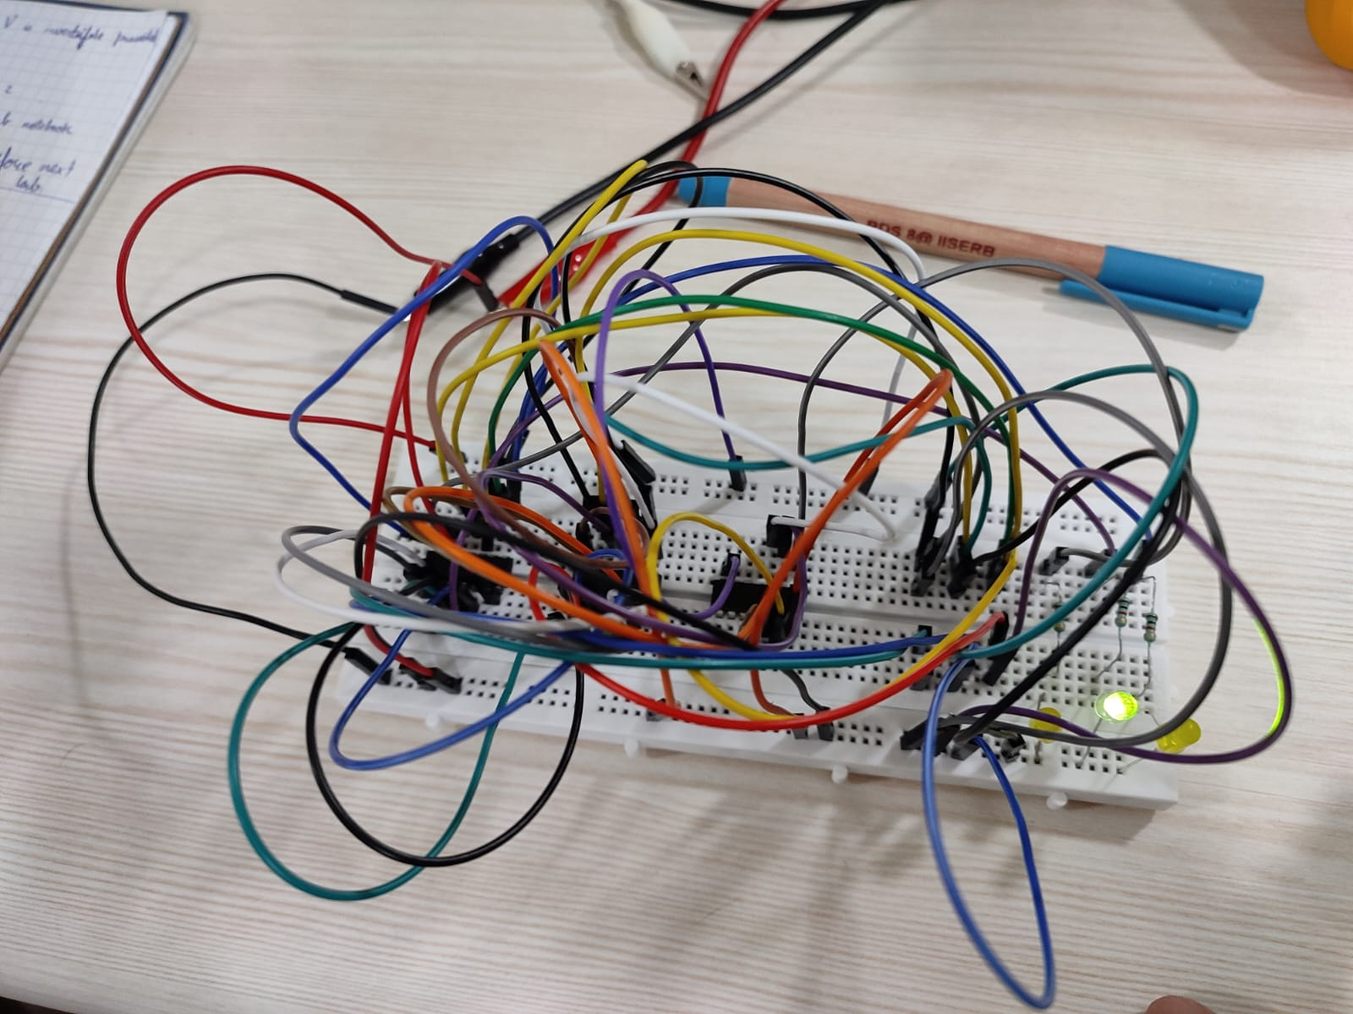

# Truth table

|  |  |  |  |  |
| --- | --- | --- | --- | --- |
| A | B | C-in | Sum | C-out |
| 0 | 0 | 0 | 0 | 0 |
| 1 | 0 | 0 | 1 | 0 |
| 0 | 1 | 0 | 1 | 0 |
| 1 | 1 | 0 | 0 | 1 |
| 0 | 0 | 1 | 1 | 0 |
| 1 | 0 | 1 | 0 | 1 |
| 0 | 1 | 1 | 0 | 1 |
| 1 | 1 | 1 | 1 | 1 |

# Block diagram

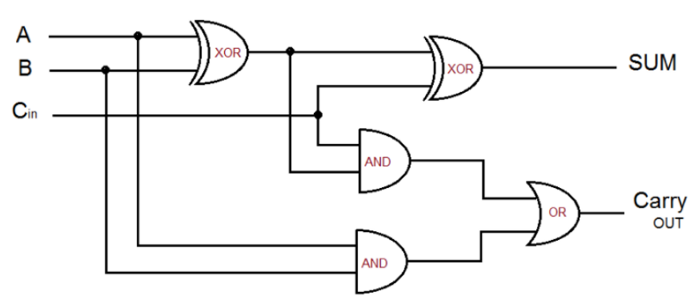

(A XOR B)*C

A*B + (A XOR B) * C

A*B

A XOR B

(A XOR B) XOR C

# Procedure

* Connect the circuit as shown in the circuit diagram.
* Check the LEDs before connecting to the circuit. (Connect anode to positive and cathode to negative terminals of the battery)
* Don’t increase the supply voltage by more than 5V.
* For logic 1 as input, connect the respective terminal to +VCC.
* For logic 0 as input, connect the respective terminal to Ground.

# Observation

|  |  |  |
| --- | --- | --- |
|  |  | Carry In = 1 |
|  | A1 = 1 | A0 = 0 |
|  | B1 = 0 | B0 = 0 |
| Carry out = 0 | SUM0 = 1 | SUM1 = 1 |

|  |  |  |
| --- | --- | --- |
|  |  | Carry In = 0 |
|  | A1 = 1 | A0 = 0 |
|  | B1 = 1 | B0 = 0 |
| Carry out = 1 | SUM0 = 0 | SUM1 = 0 |

# K-Maps

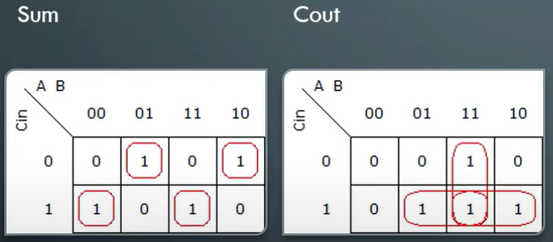

Sum of Product:

Sum=AB′Cin′+A′B′Cin+ABCin′+ACinB′

Cout=ABCin′+ACinB′+A′CinB+ABCin

Product of Sum:

Sum=(A+B+Cin)(A′+B+Cin’)(A+B′+Cin′)(A′+B′+Cin′)

Cout=(A+B+Cin)(A+B′+Cin)(A′+B+Cin)(A+B+Cin′)

# Results

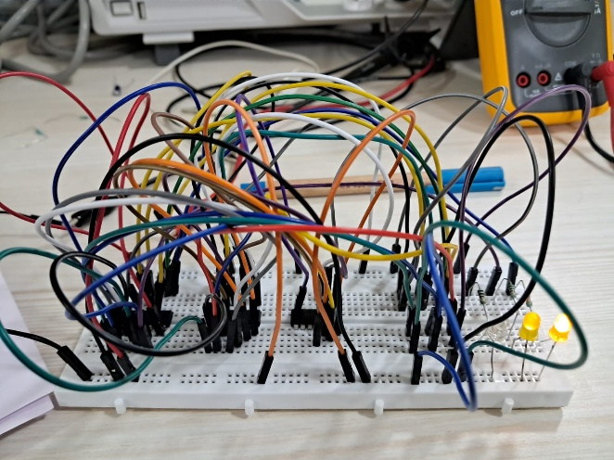 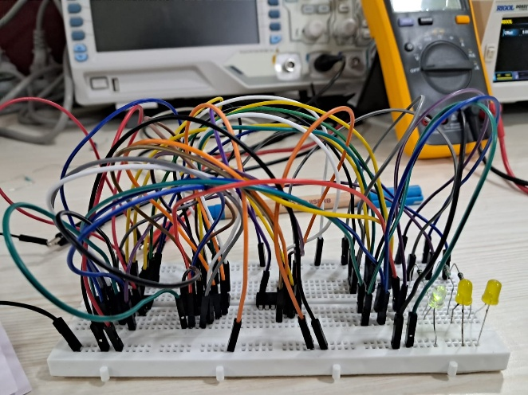

The results of observations have been attached above.

The 2-bit adder was successfully implemented and tested. The outputs matched the expected results for all input combinations, verifying the correctness of the design. Both simulation and hardware tests confirmed accurate sum and carry outputs, with no errors observed during operation.

# Conclusion

The experiment demonstrated the successful design and implementation of a 2-bit adder using basic logic gates. It provided practical insights into binary addition and combinational circuit design. The results validated the theoretical predictions, laying the groundwork for extending the design to more complex circuits like multi-bit adders.

1. INSTRUMENTATION AMPLIFIER

In partnership with Aditya Pratap Singh (22020)

# Objective

To design an instrumentation Amplifier for the given specifications using Op-Amp IC 741.

# Apparatus required

1. Function Generator (3 MHz)
2. DSO (30 MHz)
3. 2 Channel DC Power supply (0 – 30 V)
4. Op-Amp IC 741 x3
5. Bread Board
6. Resistors
7. Connecting wires and probes

# Circuit on breadboard

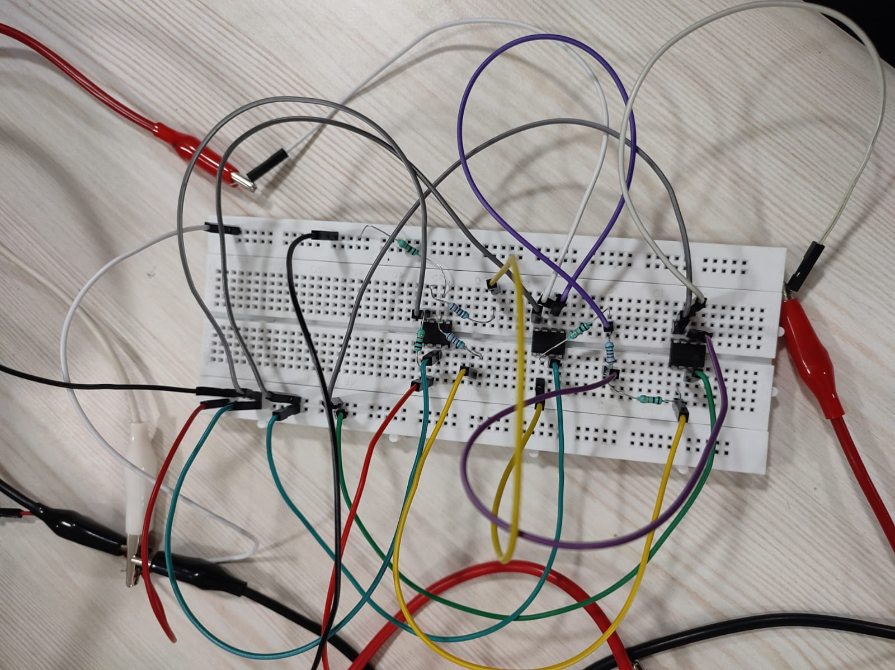

# Theory

An instrumentation (or instrumentational) amplifier is a type of differential amplifier that has been outfitted with input buffers, which eliminate the need for input impedance matching and thus make the amplifier particularly suitable for use in measurement and test equipment. Additional characteristics include very low DC offset, low drift, low noise, very high open-loop gain, very high common-mode rejection ratio, and very high input impedances. Instrumentation amplifiers are used where great accuracy and stability of the circuit, both short- and long-term are required. The most used instrumentation amplifier circuit is shown in the figure. The gain of the circuit is:

$$\frac{V_{out}}{V_{2}-V_{1}}=\left(1+\frac{2⋅R_{1}}{R_{gain}}\right)\frac{R_{3}}{R_{2}}$$

The rightmost amplifier, along with the resistors labelled $R_{2}$ and $R_{3}$ is just the standard differential amplifier circuit, with gain = $\frac{R_{3}}{R_{2}}$ and differential input resistance = $2⋅R_{1}$. The two amplifiers on the left are the buffers. With $R_{gain}$ removed (open circuited), they are simple unity gain buffers; the circuit will work in that state, with gain simply equal to $\frac{R_{3}}{R_{2}}$ and high input impedance because of the buffers. The buffer gain could be increased by putting resistors between the buffer inverting inputs and ground to shunt away some of the negative feedback; however, the single resistor $R_{gain}$ between the two inverting inputs is a much more elegant method: it increases the differential-mode gain of the buffer pair while leaving the common-mode gain equal to 1.

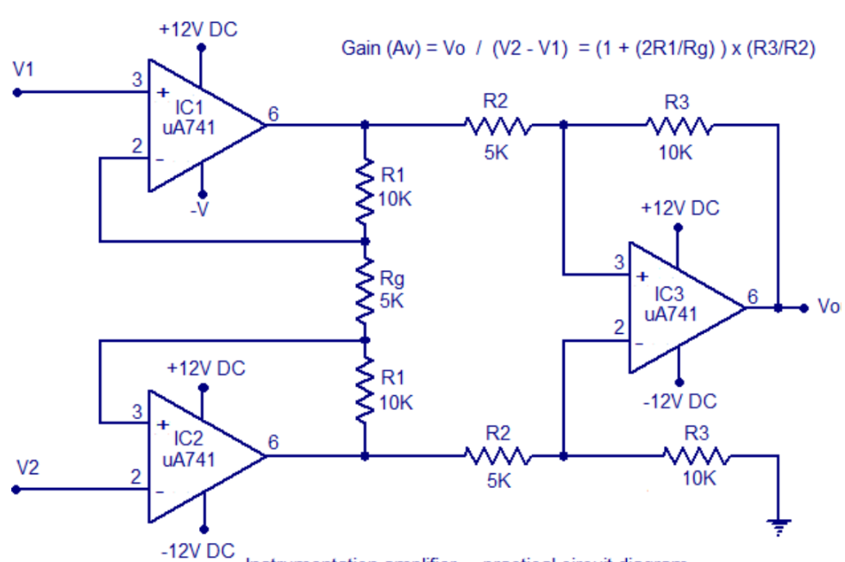

# Procedure

1. Connections are given as per the circuit diagram.
2. +Vcc and -Vcc supply is given to the power supply terminal of the Op-Amp IC.
3. By adjusting the amplitude and frequency value of the sine wave in the function generator, t he appropriate input voltage is applied to the input terminal of the Op-Amp.
4. The output voltage is obtained in the DSO.

# Observation

|  |  |  |  |  |
| --- | --- | --- | --- | --- |
| V1 | V2 | Rg | Theoretical  (V0) | Practical  (V0) |
| 5 | 5.1 | 5k | 1 | 1.21 |
| 6 | 6.1 | 5k | 2 | 2.30 |
| 7 | 7.1 | 5k | 3 | 3.42 |

# Results

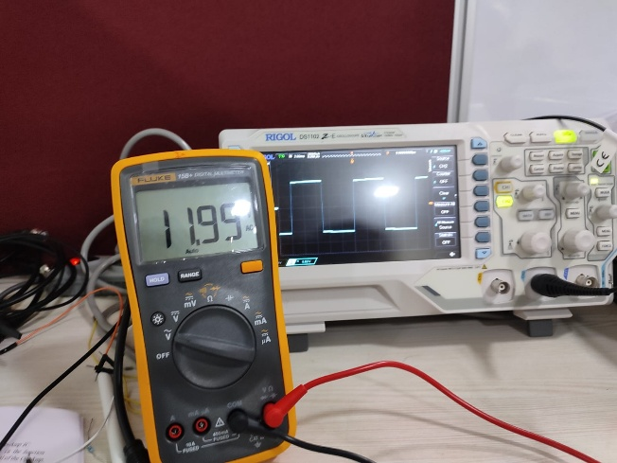 The instrumentation amplifier was successfully designed and implemented using the Op-Amp IC 741. The amplifier achieved the specified gain of [insert gain value] with minimal distortion and a high input impedance, ensuring accurate signal measurement. The output voltage closely followed theoretical predictions, demonstrating stable operation across the input range.

# Conclusion

The experiment confirmed the successful design and functionality of the instrumentation amplifier. By utilizing IC 741, the amplifier provided precise signal amplification with high common-mode rejection, making it suitable for low-level signal measurements. The results demonstrated the practical application of operational amplifiers in instrumentation and sensor interfacing.

1. Arduino – I

In partnership with Aditya Pratap Singh (22020)

# Objective

# Blink the on-board LED.

# Blink an external LED.

# Blink LED (inbuilt and external) without time-delay function.

# Read analog value of voltage by connecting a 10 kΩ pot.

# Vary the brightness of an external LED through a pot (10 kΩ).

# Theory

Arduino is an open-source electronics platform based on easy-to-use hardware and software. Arduino boards are able to read inputs - light on a sensor, a finger on a button, or a Twitter message - and turn it into an output - activating a motor, turning on an LED, publishing something online. You can tell your board what to do by sending a set of instructions to the microcontroller on the board. To do so you use the Arduino programming language (based on Wiring), and the Arduino Software (IDE), based on Processing.

## How to connect to an Arduino board

1. Install ARDUINO IDE software on your PC.
2. Connect the Arduino board with your PC through USB cable.
3. Run ARDUINO IDE software on your PC.
4. Click on tools option as shown in Figure 2.
5. Select the board.
6. Select the port.
7. Now your board is ready to do programming.

# Blinking on board light

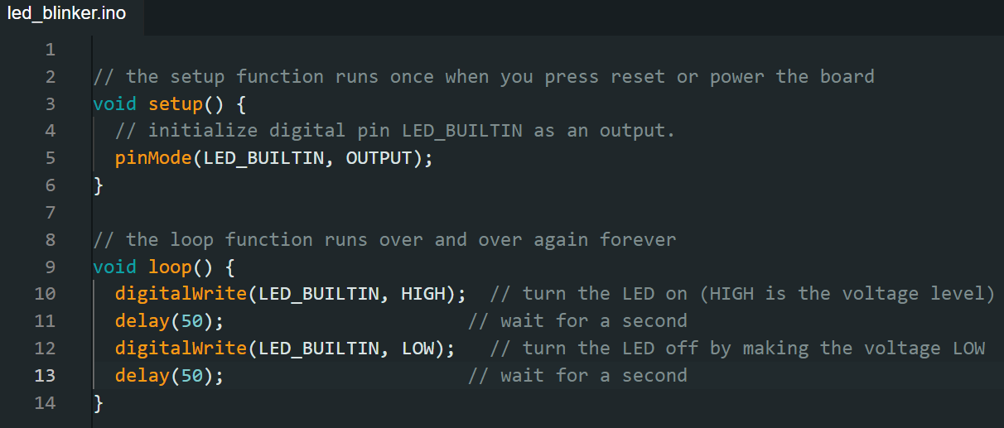

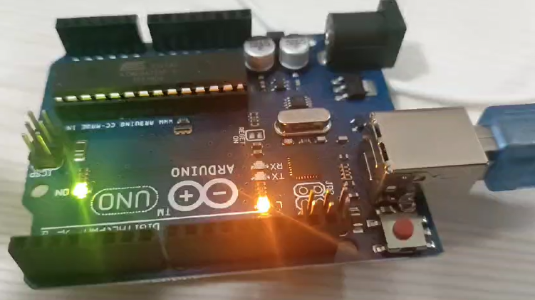 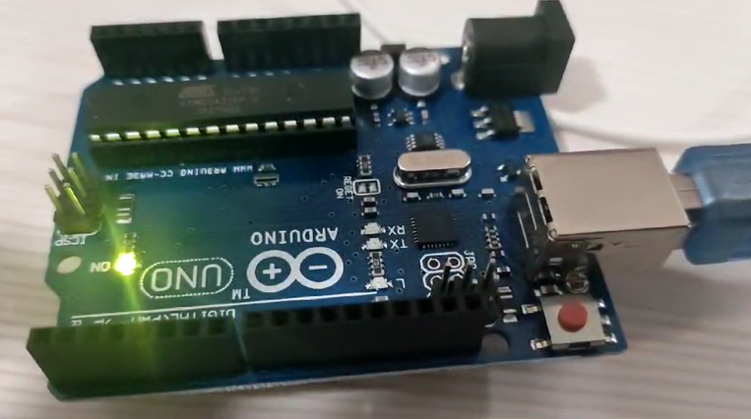

# Blinking external LED

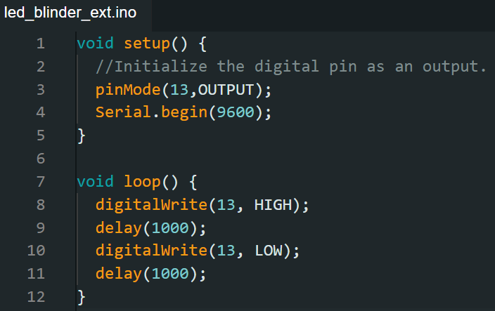

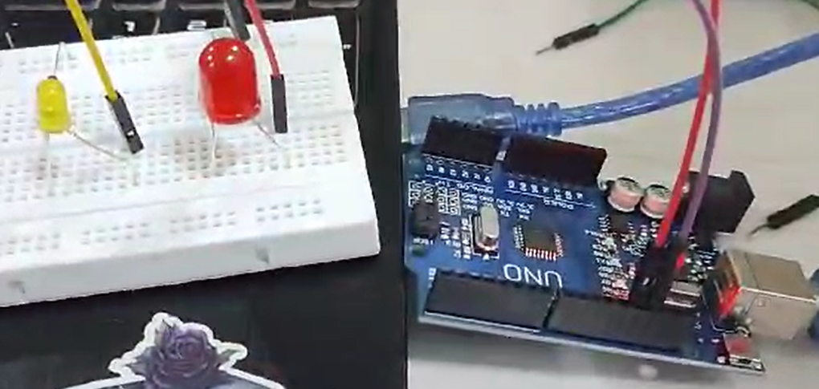

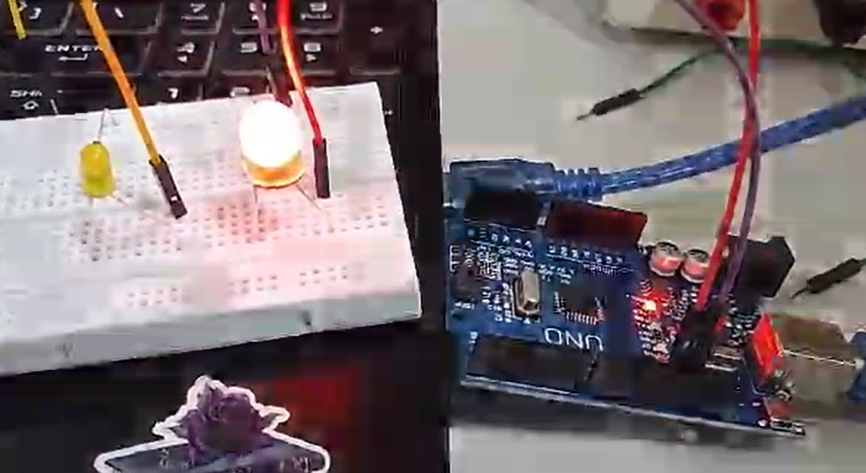

# Blinking LED without using delay

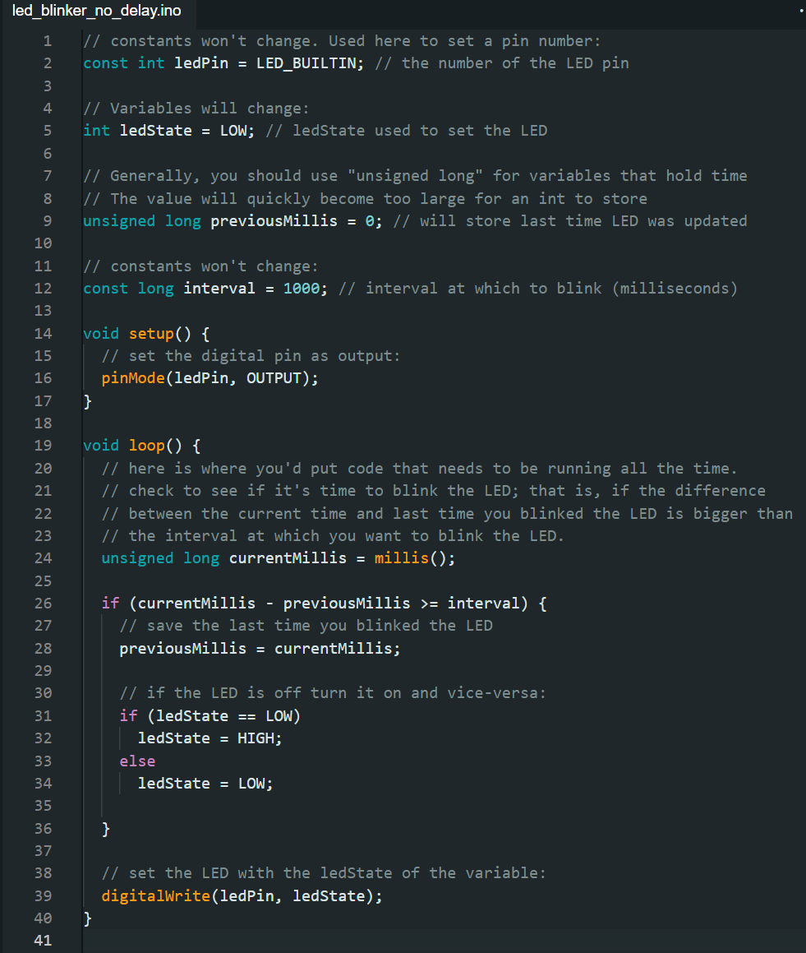

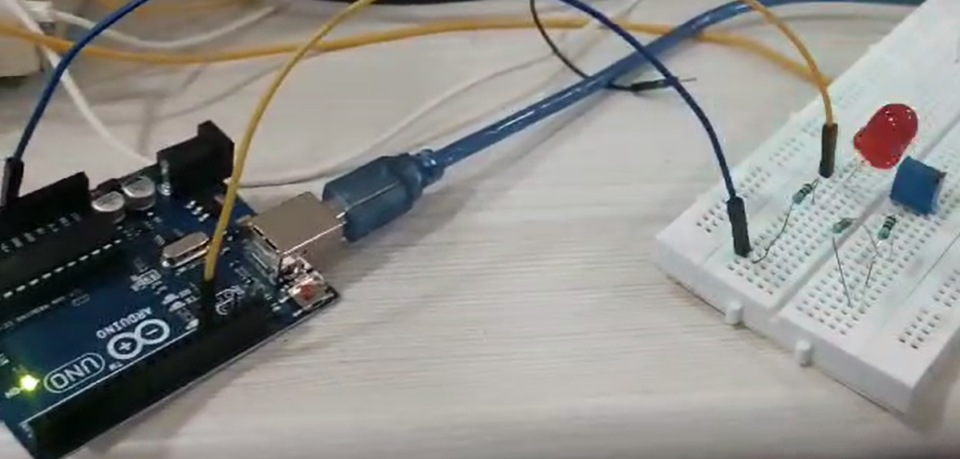 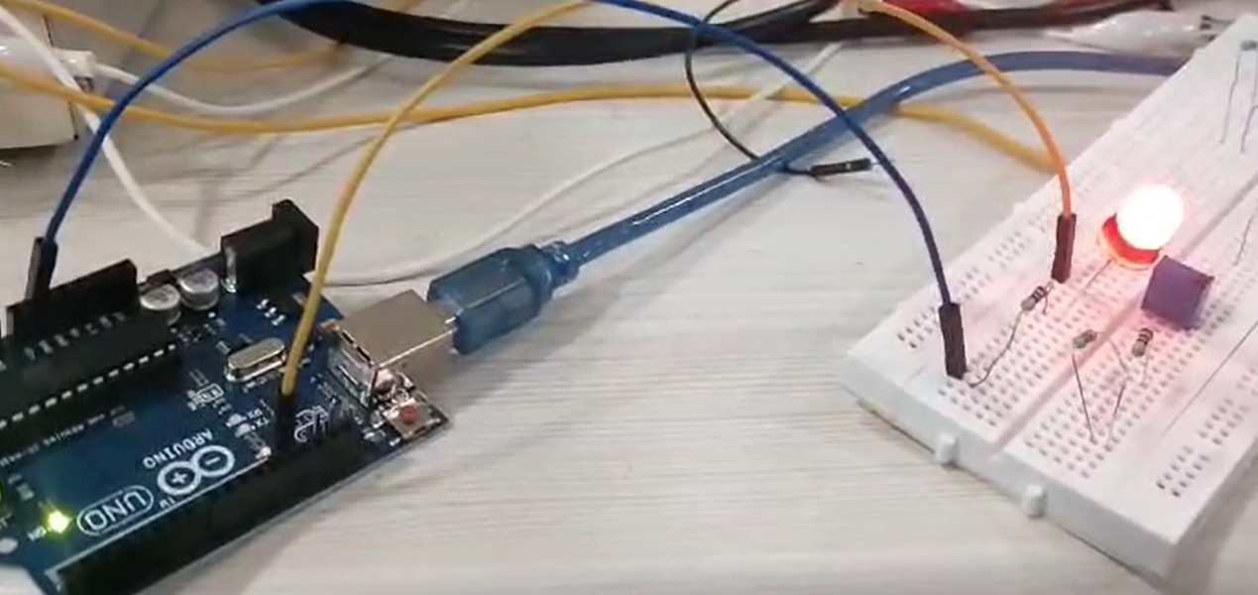

# Brightness controller for LED

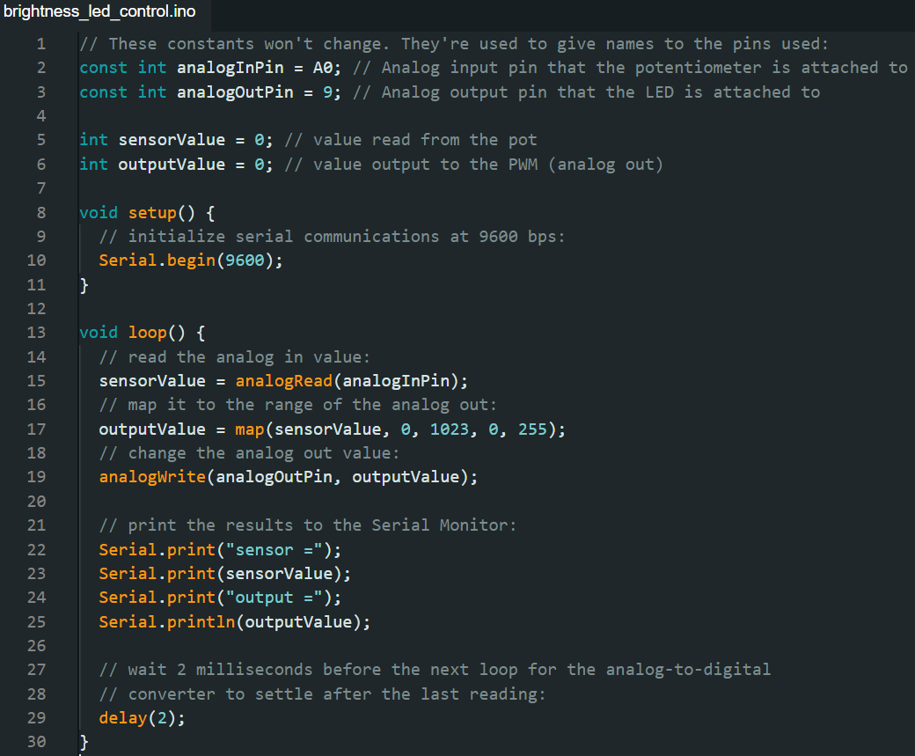

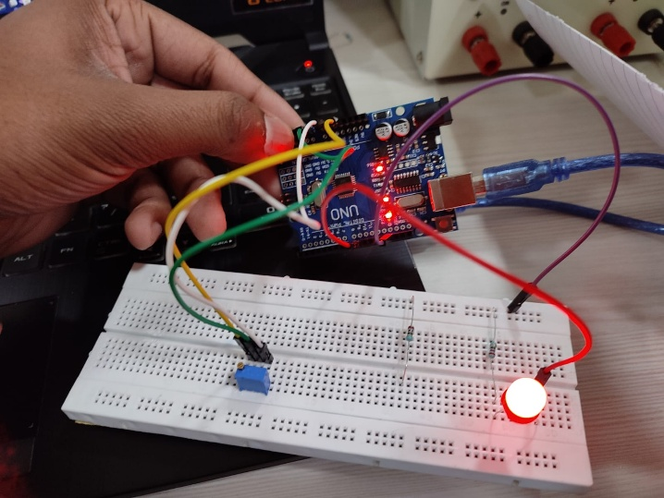 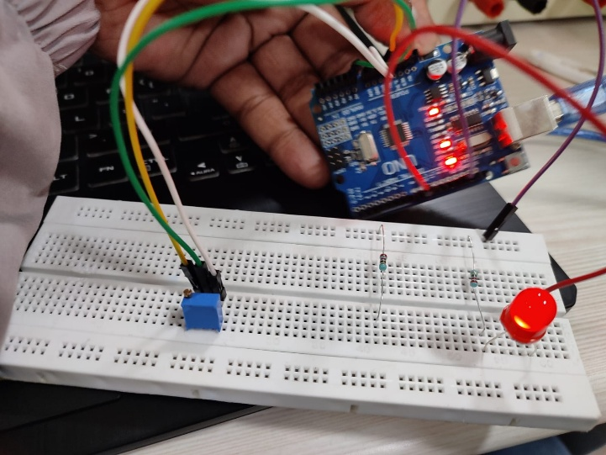

# Analog reader

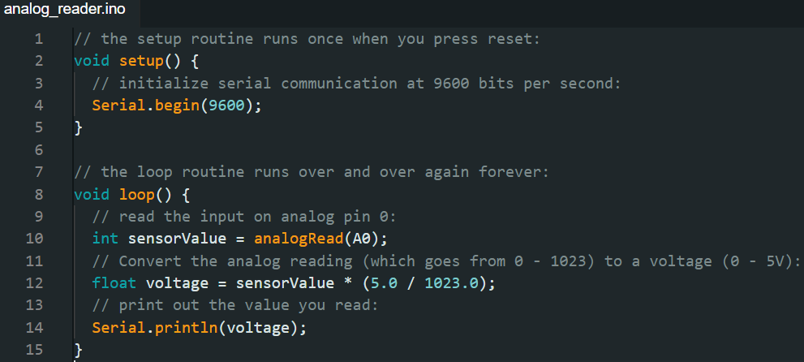

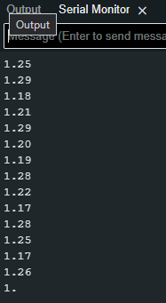 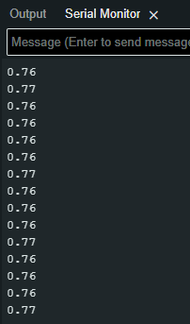

# Results

The on-board and external LEDs were successfully blinked using both the delay() function and a non-blocking method with the millis() function. Both LEDs could operate simultaneously without interfering with other processes.

The analog voltage from a 10 kΩ potentiometer was read and displayed using the microcontroller's ADC. The potentiometer was also used to vary the brightness of an external LED by mapping the analog values to a PWM signal, providing smooth brightness control.

# Conclusion

The experiment successfully demonstrated basic microcontroller functions, including LED blinking, analog input reading, and PWM-based brightness control. Using a potentiometer to control LED brightness showcased how input devices can interact with output devices.

The use of non-blocking techniques, such as millis(), enabled multitasking in the program, highlighting efficient programming practices for embedded systems. These tasks are foundational for understanding microcontroller operations in more complex applications.

1. Arduino – II

In partnership with Aditya Pratap Singh (22020)

# Objectives

1. Design the Arduino Circuit to measure the temperature by using temperature sensor (LM35) such that for temperature > 27°C red led will glow and for temperature < 27°C yellow led will glow.
2. Design the Arduino Circuit display the 0-9 digits on seven segment display.
3. Design the Arduino Circuit to measure the temperature by using temperature sensor (LM35) and display it on seven segment display (2 digits).

# Objective 1

## Code

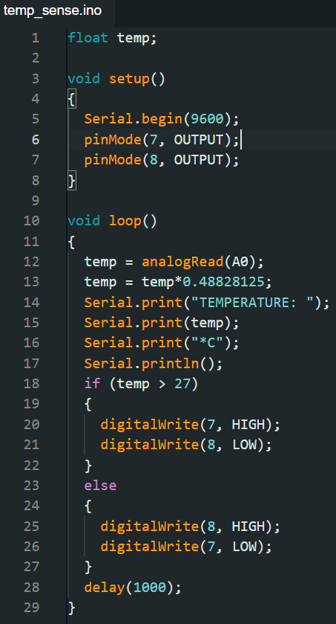 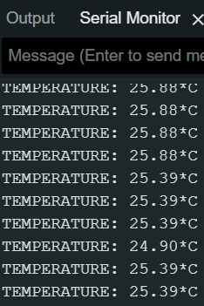

## Circuit and Output

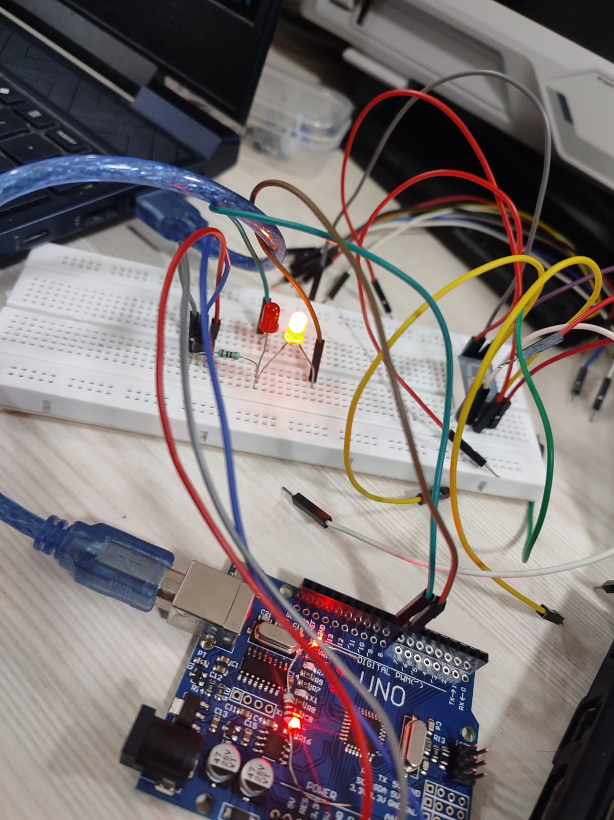 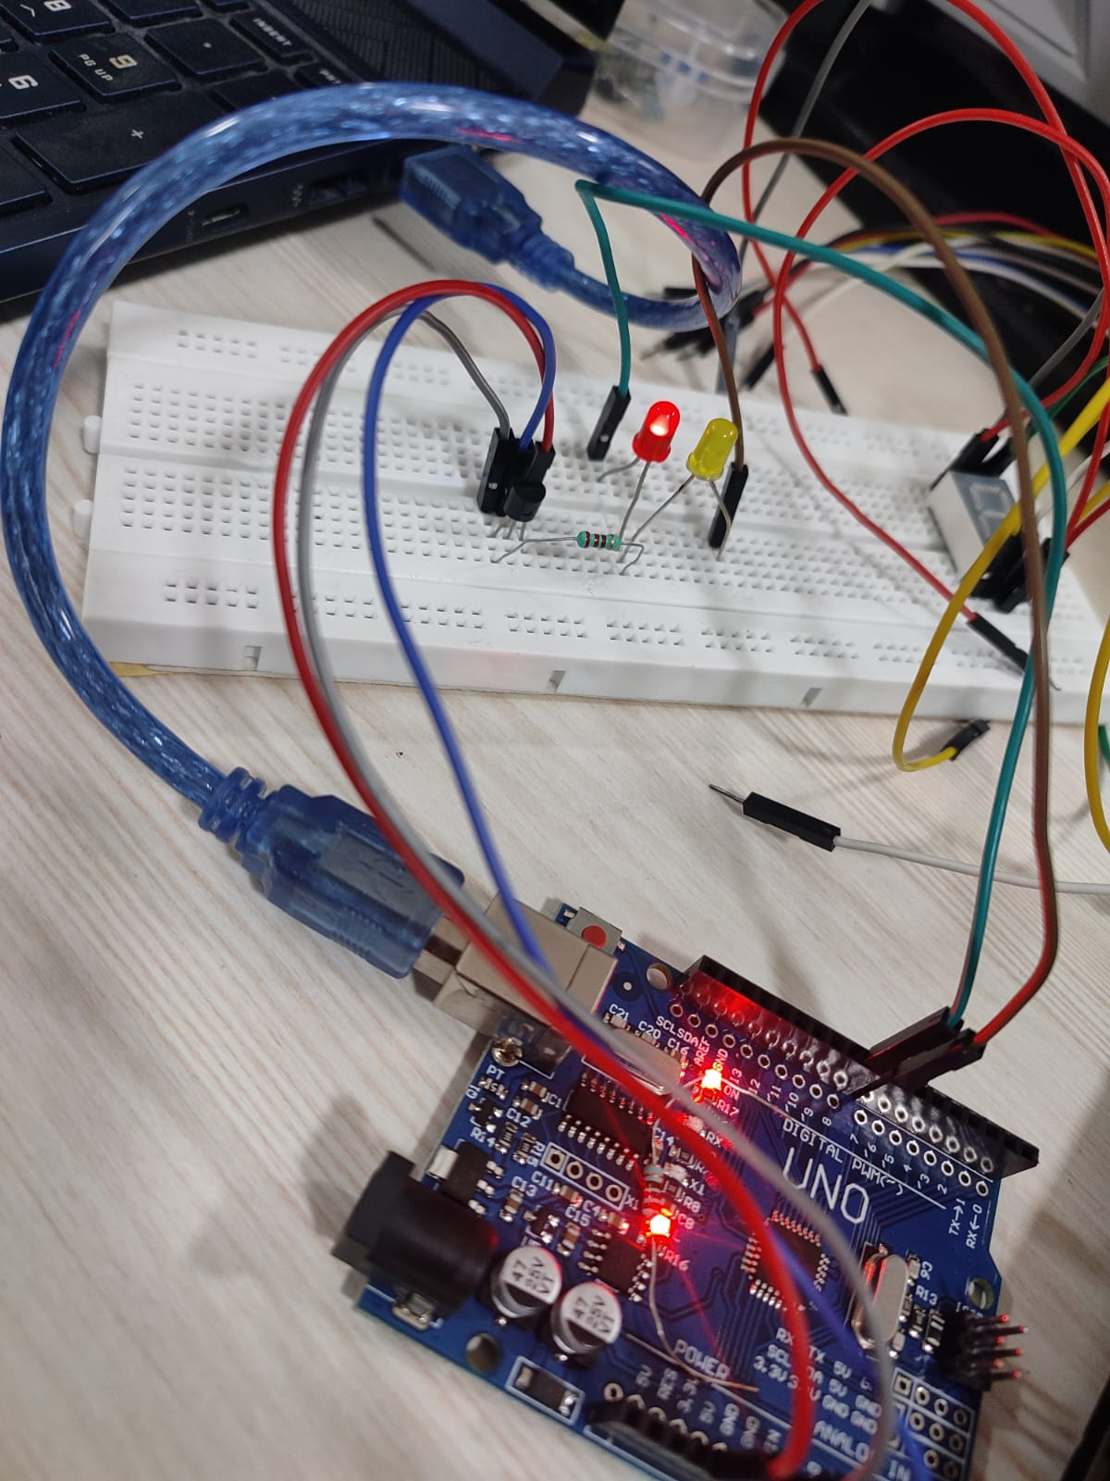

## Result and Conclusion

Setting the threshold temperature to 27°C since the room temperature was around 25°C, the led changes it’s state when we hold the sensor for some time. Holding causes increase in temperature and the code then changes the state of lights when the temperature it reads exceeds 27°C.

Thus, the experiment demonstrates the working of temperature sensor and how to read the values in Arduino and control other digital equipment such as led based on that.

# Objective 2

## Code

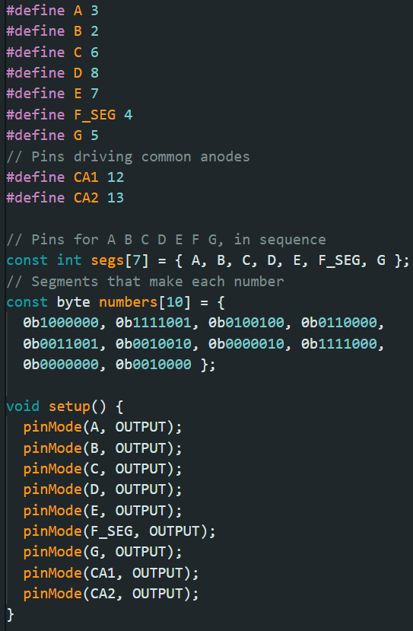 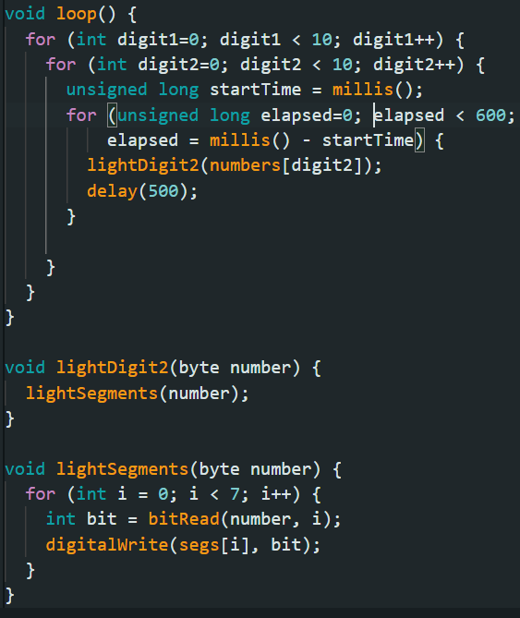

## Circuit and Output

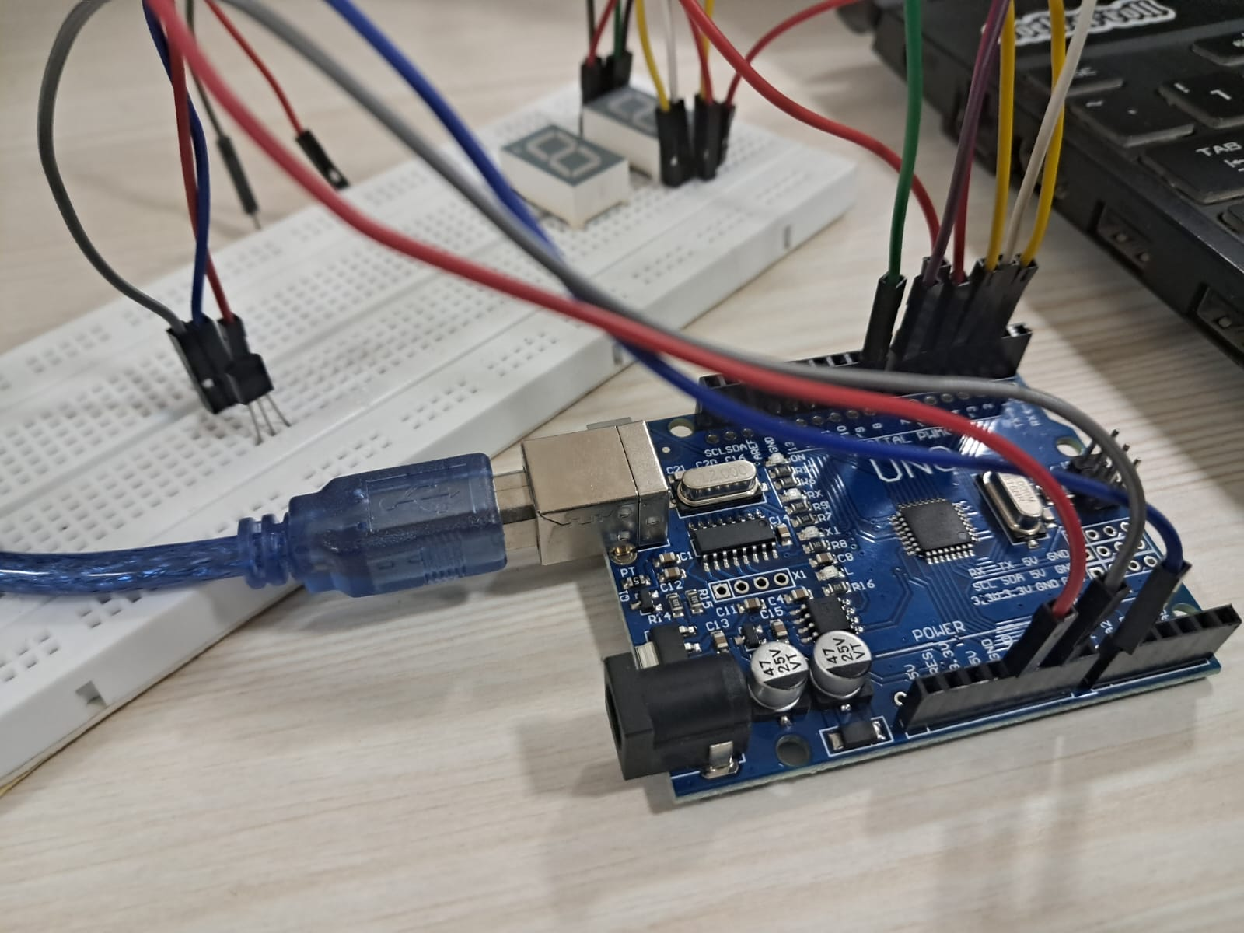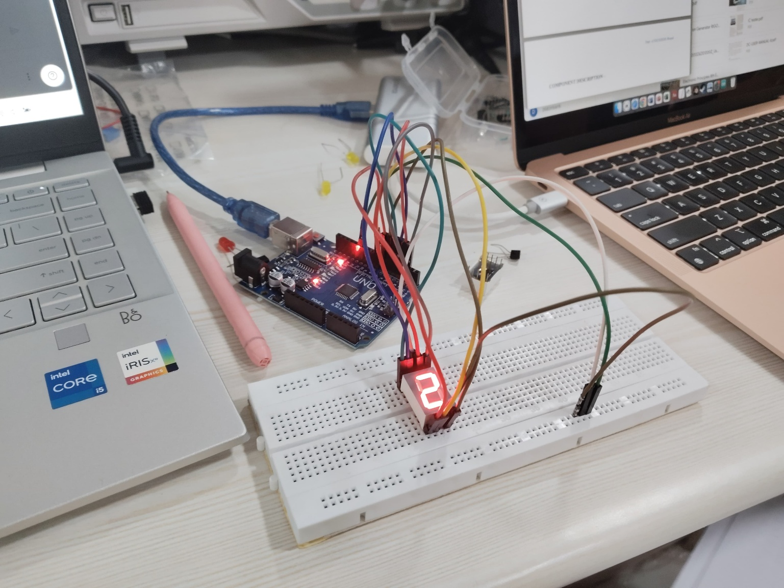

## Result and Conclusion

The experiment successfully displayed digits 0-9 on a seven-segment display using Arduino. Clear and accurate digit representation was achieved, demonstrating efficient control of digital displays. This experiment serves as a basic foundation for applications like counters and timers in embedded systems.

# Objective 3

## Code

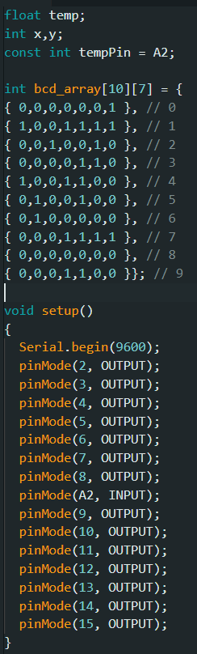 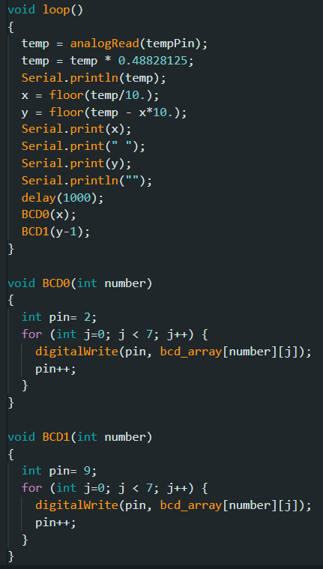

## Circuit and Output

## Result and Conclusion

The experiment successfully demonstrated the ability to measure and display temperature using an LM35 sensor and a two-digit seven-segment display. The LM35 provided an accurate analog voltage output corresponding to the ambient temperature, which was processed by the Arduino and displayed in real time. By utilizing 74HC595 shift registers, the number of required Arduino pins was minimized, making the circuit more efficient. The system provided stable and consistent readings, proving its reliability for basic temperature monitoring applications. This experiment highlighted the practical application of sensors and microcontrollers in real-world scenarios, such as digital thermometers and environmental monitoring systems. The project can be further improved by incorporating additional features like temperature alerts or LCD screens for enhanced readability.

1. BCD to 7-Segment Display

In partnership with Aditya Pratap Singh (22020)

# Objective

Design a circuit to decode BCD (binary coded decimal) to decimal number (0 to 9) using a 7-segment LED display.

# Required Components

* BCD to 7-segment LED IC (74LS47)
* 7-segment LED display
* Resistor × 7 (220 Ω/470 Ω)
* Resistor × 4 (1 kΩ)
* 5 V DC power supply
* Connecting wires
* Multimeter

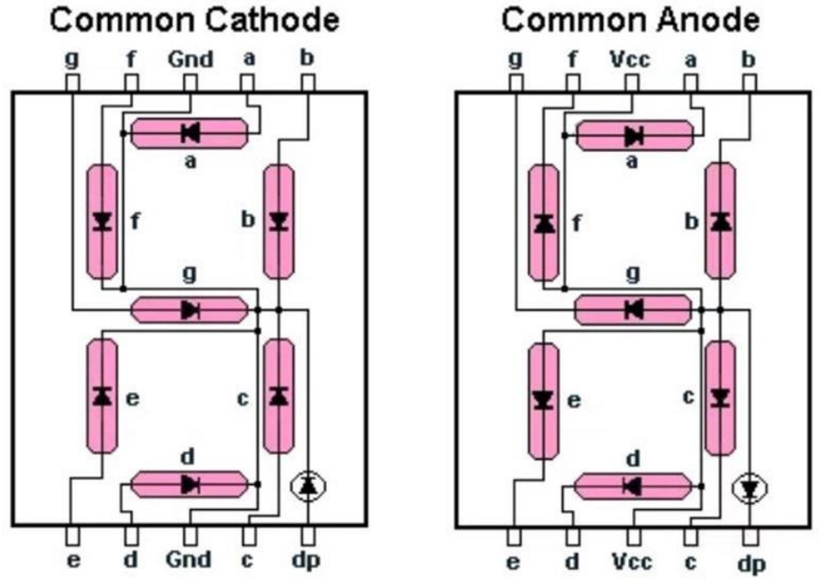

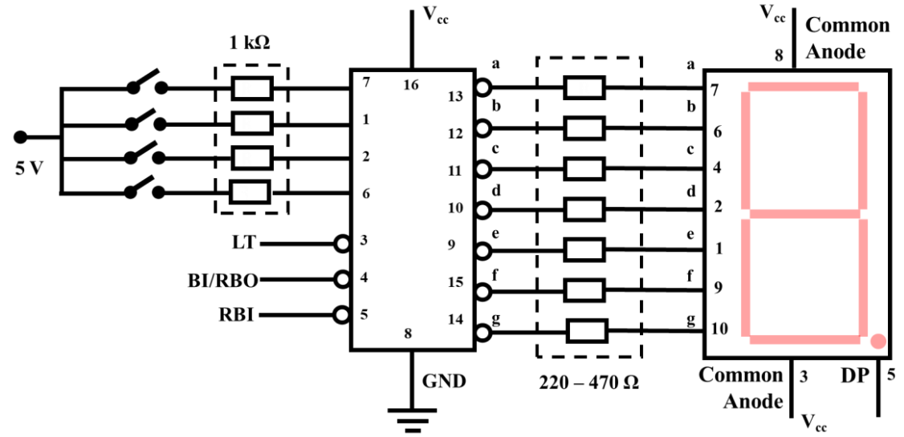

# Output

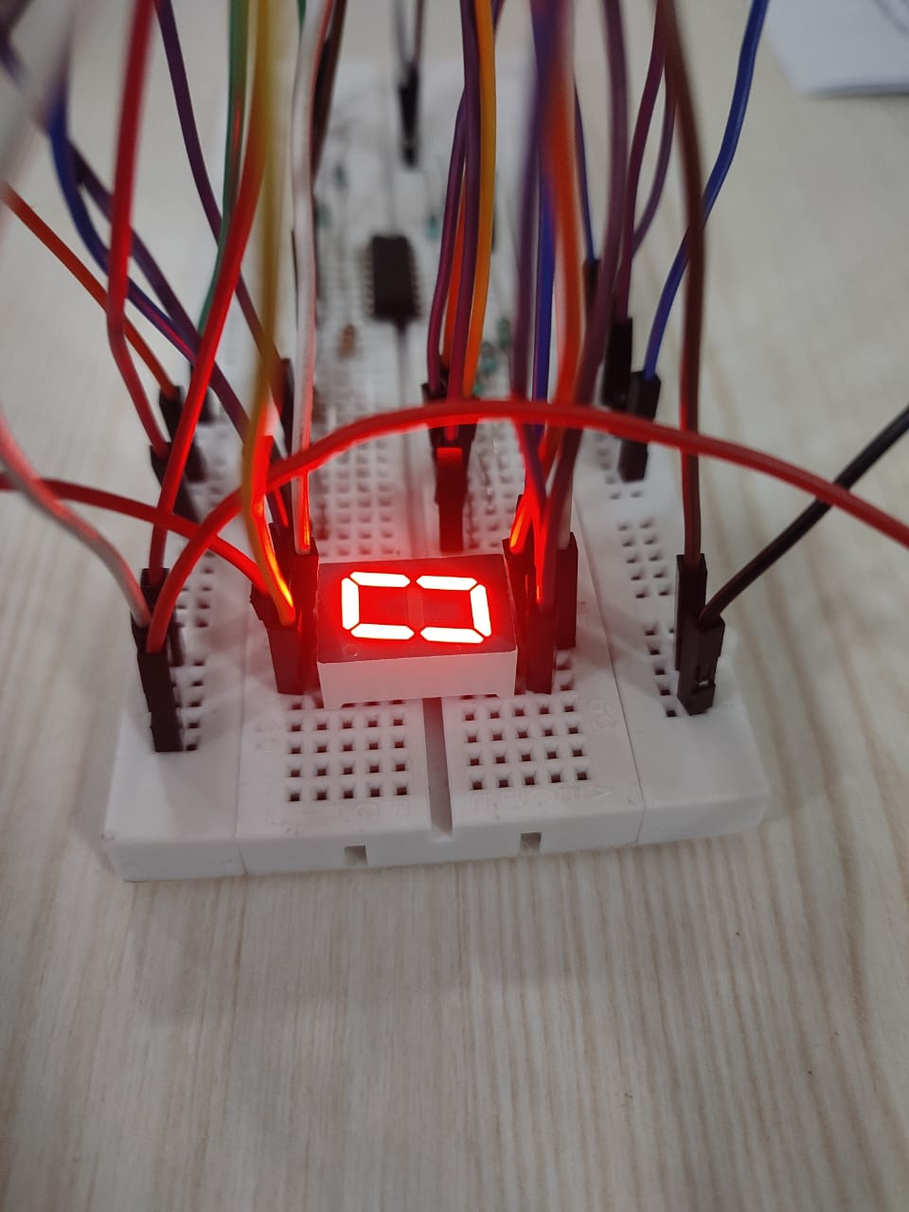 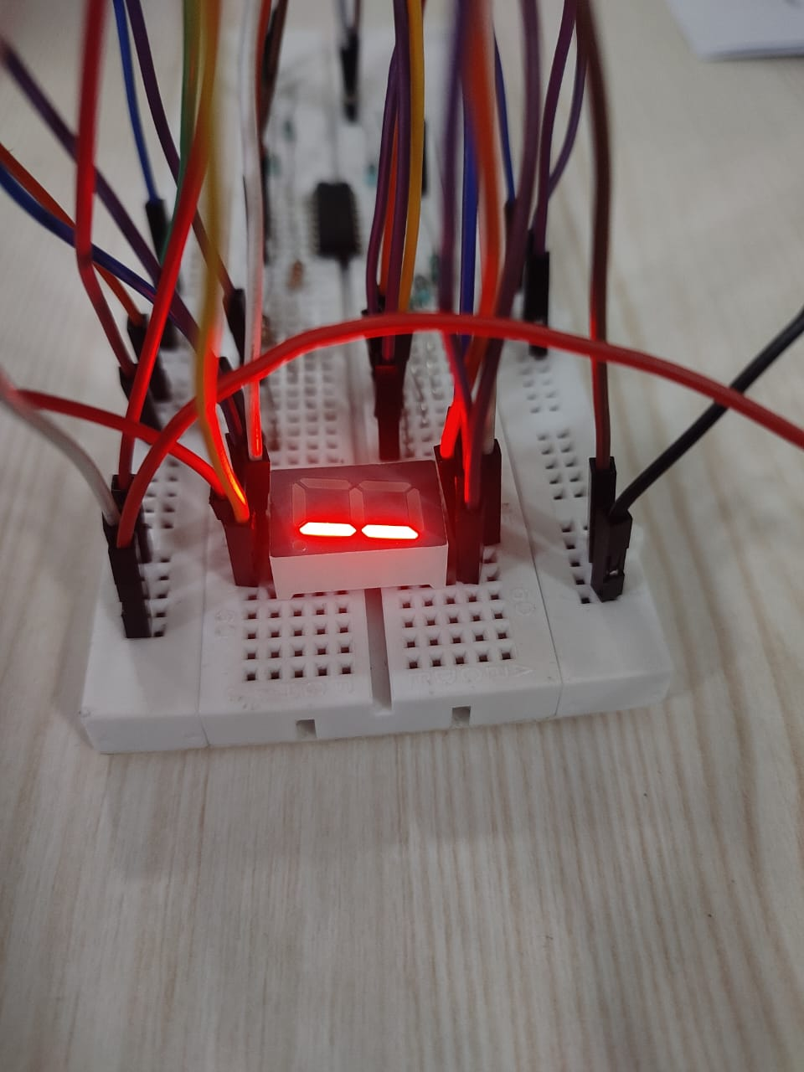

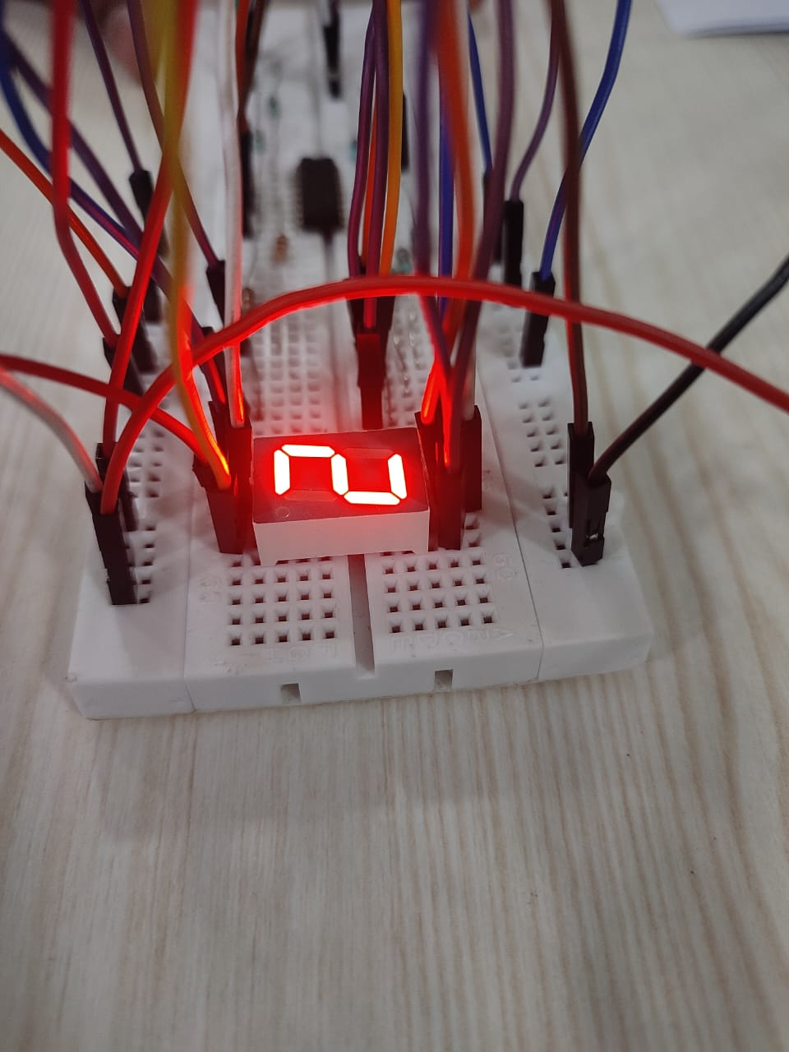 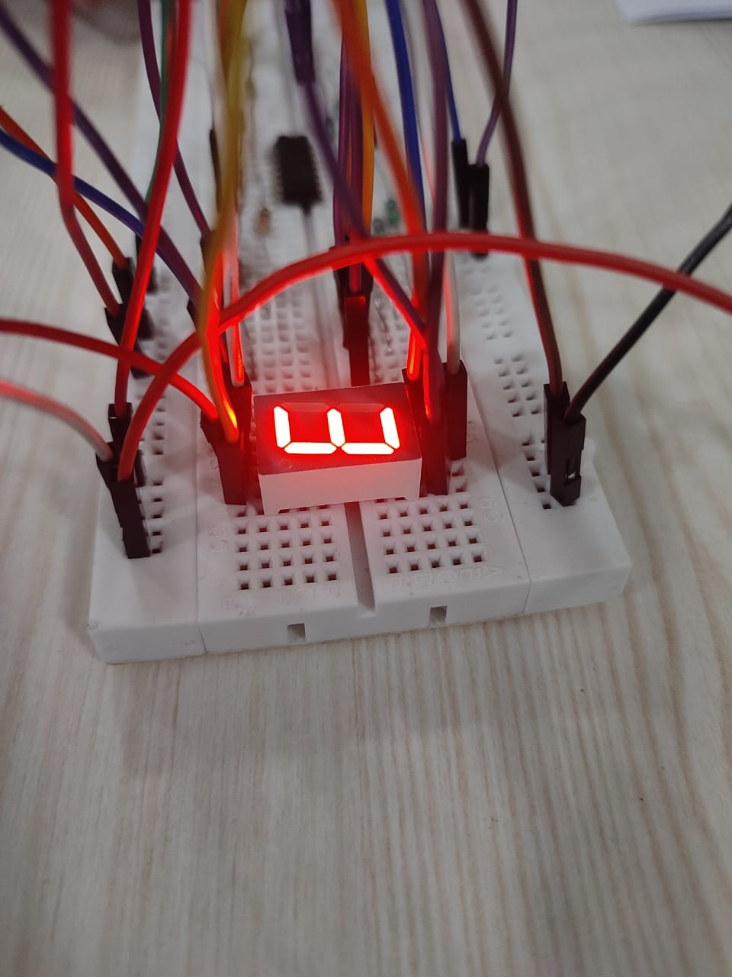

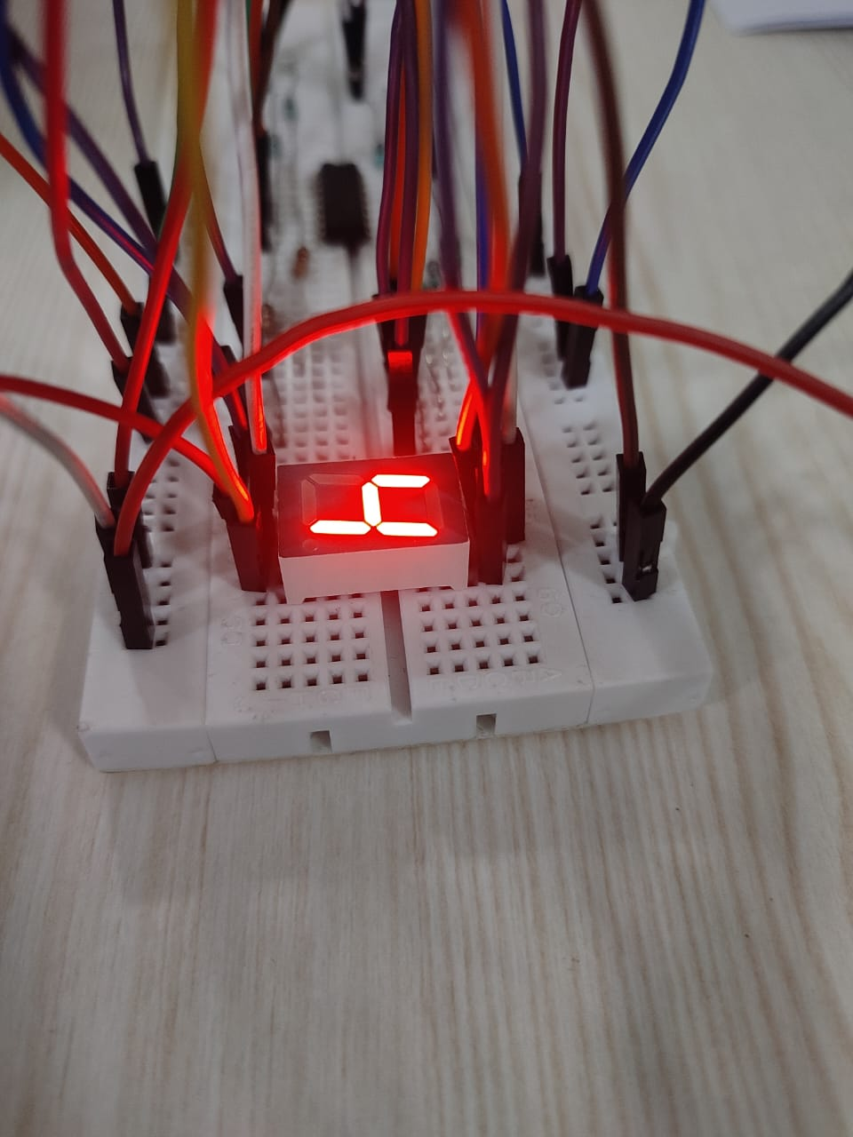 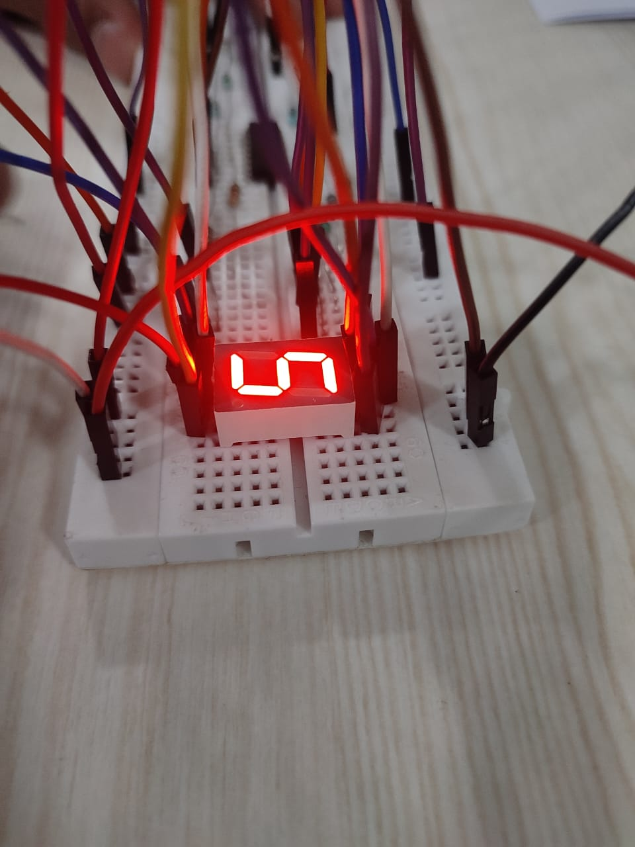

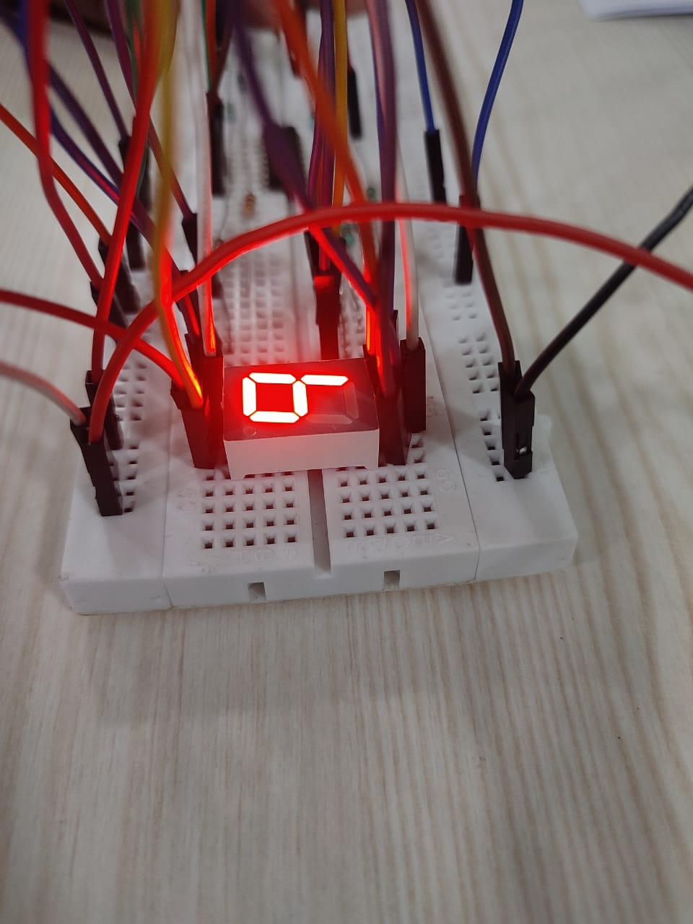 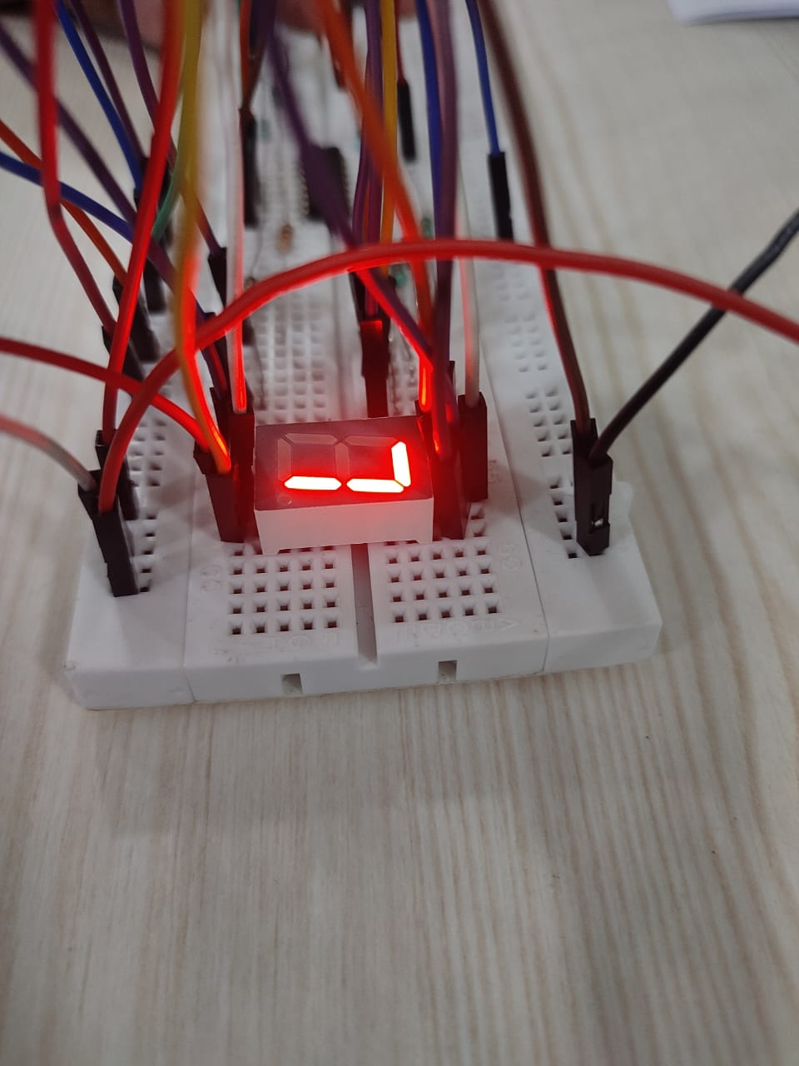

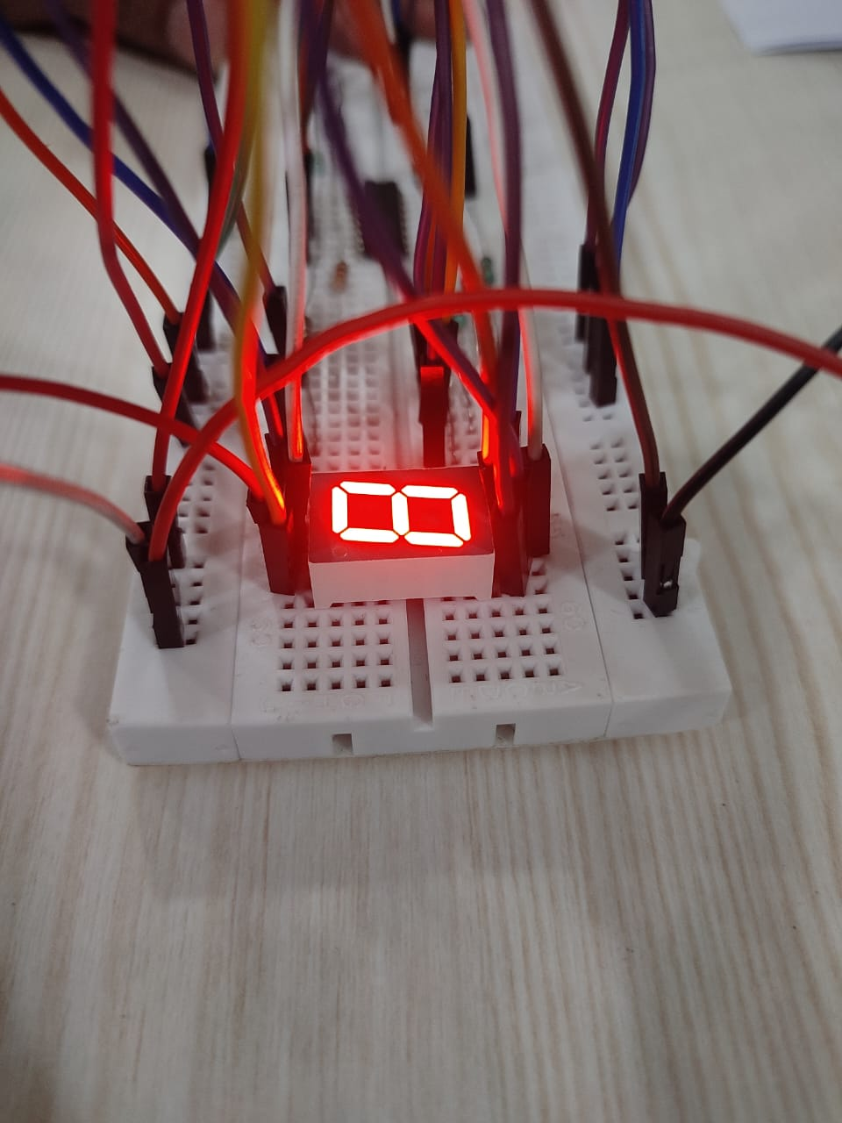 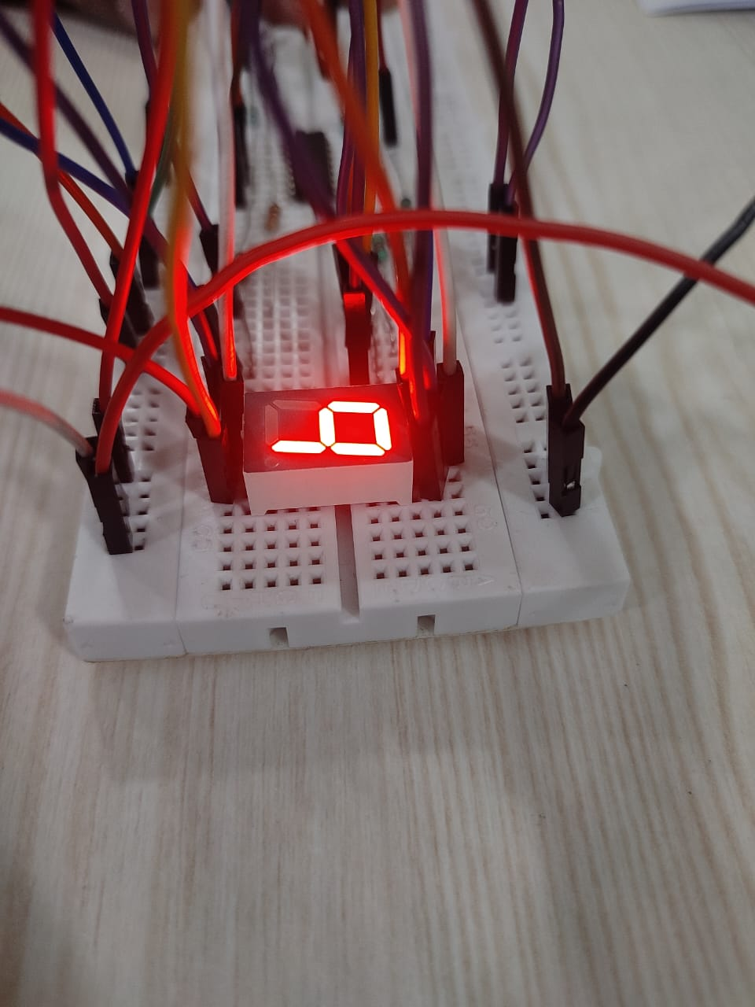

# Result and Conclusion

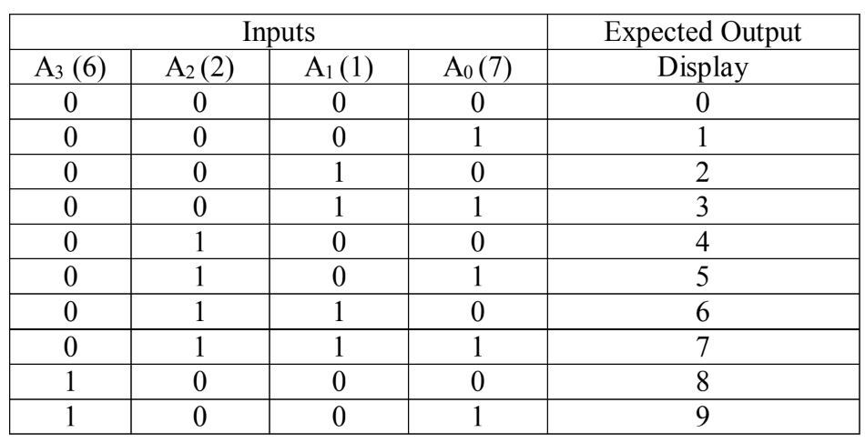

The designed circuit successfully decodes a Binary Coded Decimal (BCD) input (0000 to 1001) into its corresponding decimal representation on a 7-segment LED display. By using a BCD to 7-segment decoder (from 0 to 9), the circuit simplifies the conversion process, ensuring correct segment illumination. The experiment verifies the accurate display of decimal digits, demonstrating the effective working of digital logic in numeric displays.

1. SR Latch

In partnership with Aditya Pratap Singh (22020)

# Objectives

1. Design SR flip flop using NAND gates.
2. Design SR flip flop using NOR gates.
3. Verify and test type1 and type2 SR latch using SR latch IC 74LS279.

# SR Flip Flop using NAND Gates

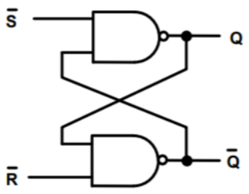 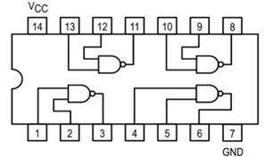

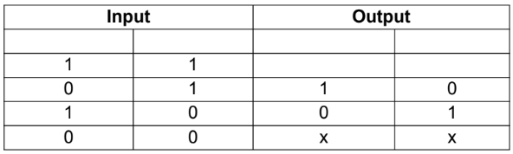

## Observation

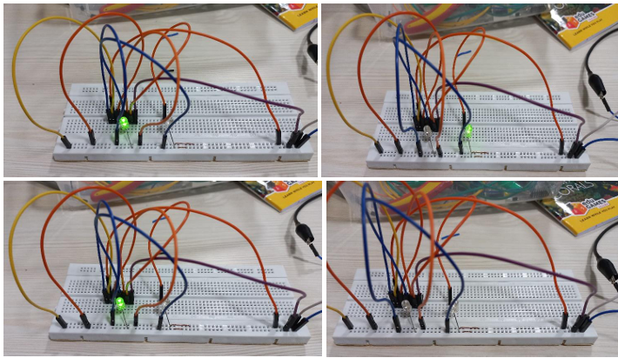

# SR Flip Flop using NOR Gates

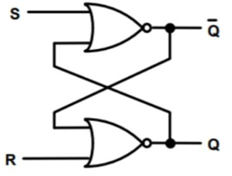 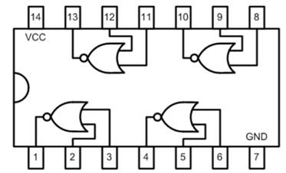

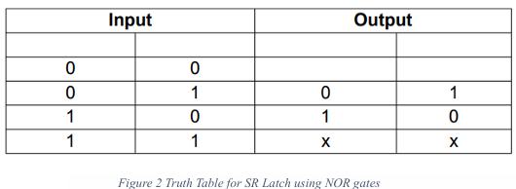

## Observations

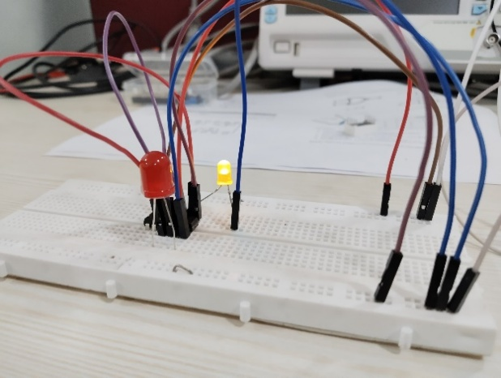 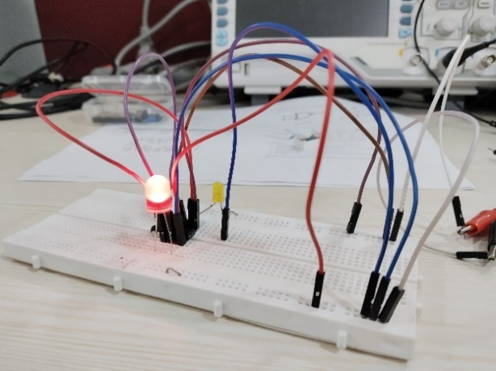

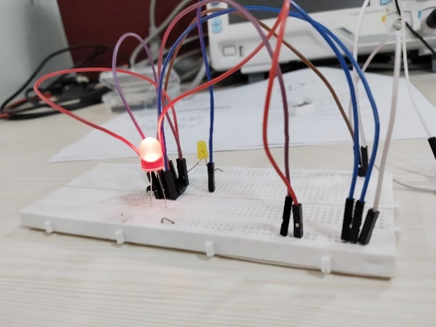 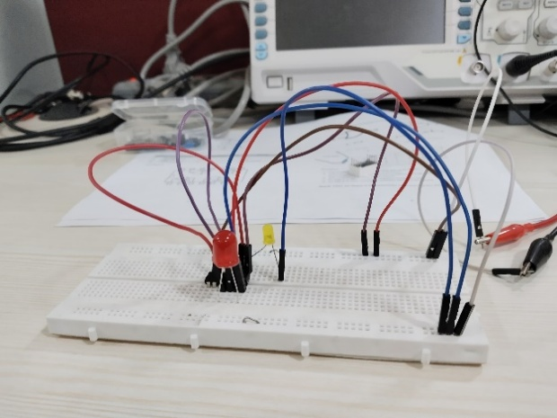

# Type 1 and 2 SR Latch using IC

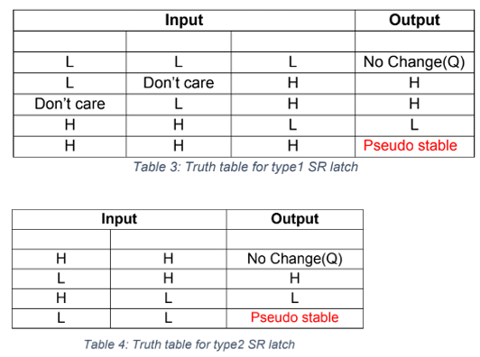

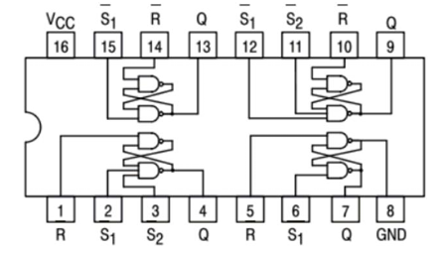

## Observations

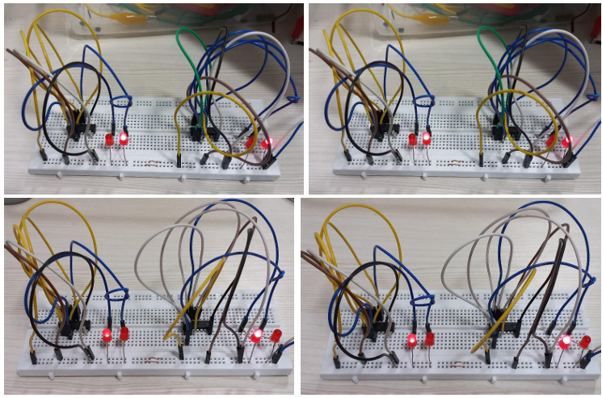

# Results and Conclusion

1. The SR flip-flop using NAND gates works in active-low logic and behaves according to its truth table.
2. The SR flip-flop using NOR gates work in active-high logic, also matching expected behaviour.
3. The IC 74LS279 successfully implements both Type1 and Type2 SR latches and verifies the latch behaviour.

* SR flip-flops can be effectively implemented using basic logic gates (NAND or NOR).
* The logic level of inputs (active-high or active-low) changes how the flip-flop reacts.
* The IC 74LS279 simplifies SR latch implementation and confirms theoretical design via hardware.
* Care must be taken to avoid invalid states where both S and R are active simultaneously.

1. JK Flip Flop

In partnership with Aditya Pratap Singh (22020)

# Objectives

In this lab session we learnt about the working of JK flip flop and used it to create a frequency divider.

1. Familiarize yourself with the connection diagram, function table, and recommended operating conditions for the IC 74HC73N.
2. Verify the function table of the IC 74HC73N. Note down the outputs for various input settings.
3. Create frequency divider for f/4. That is, design a circuit such that, if the input clock frequency to the circuit is f, the circuit generates a square wave of frequency f/4. Record your output for input signals of different frequencies.

# A diagram of a circuit board AI-generated content may be incorrect.Materials Required

* Connecting Wires
* Breadboard
* JK Flip Flop IC (74HC73N)
* Resistor (220Ω x2)
* External LED x2
* Oscilloscope
* Function Generator
* DC supply

# Objective 2

1. Connect the circuit as shown in the circuit diagram.
2. Supply Vcc and ground from the power supply.
3. Provide a clock pulse using a square wave from the function generator.
4. Check the output from Q and Q. Verify with the Function table.

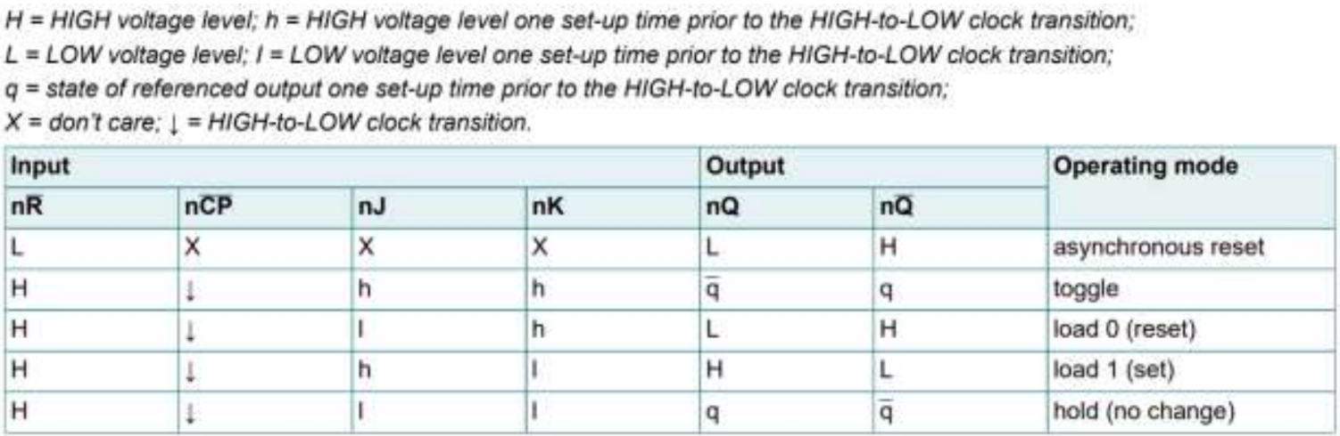

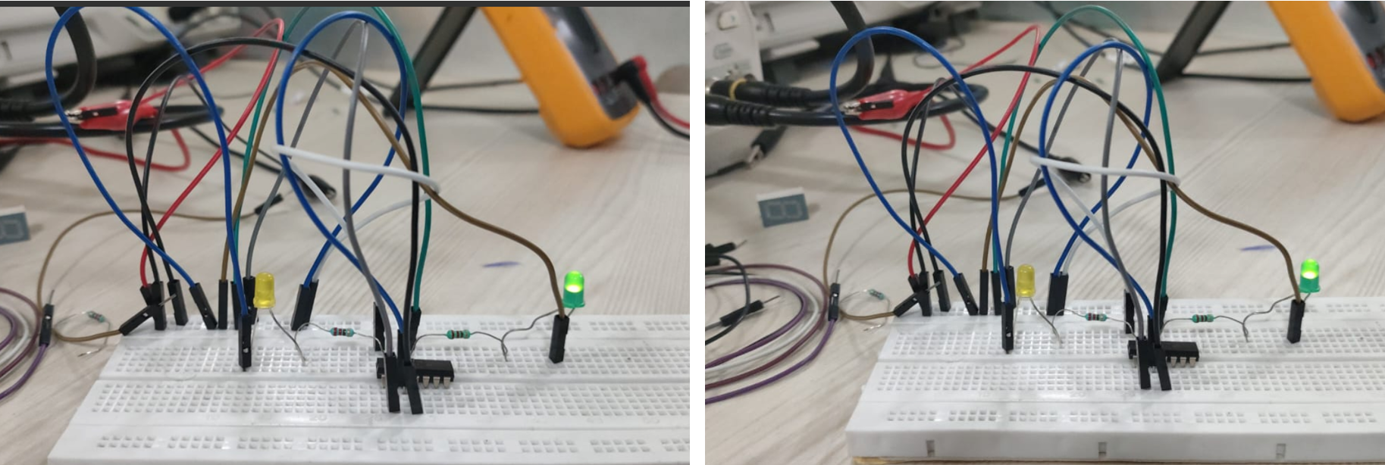

J: High ; K: Low J: Low ; K: Low (Q Hold)

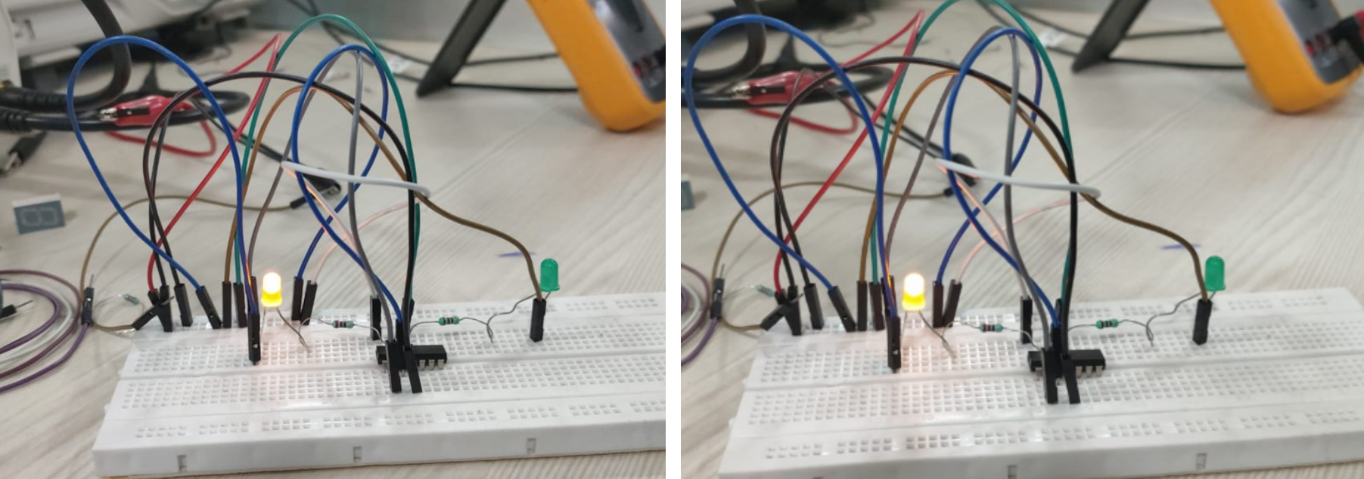

J: Low ; K: High J: Low ; K: Low (Q’ Hold)

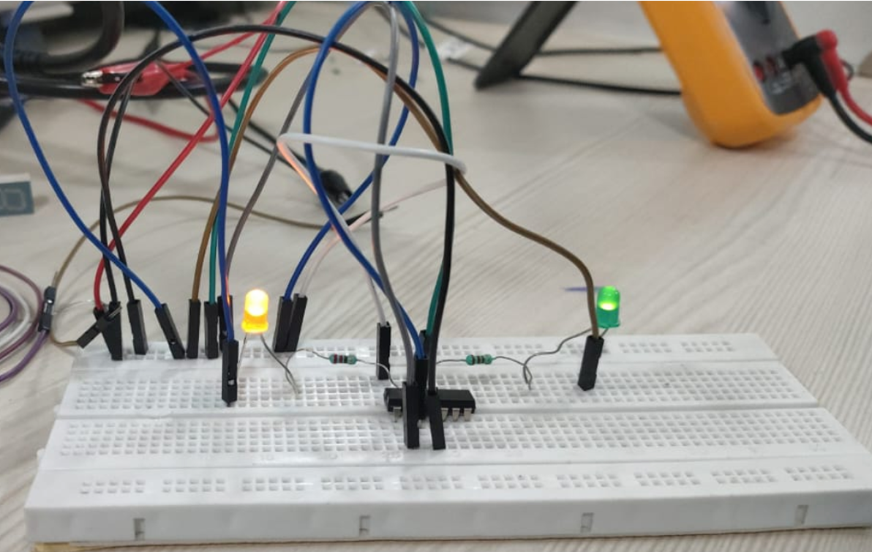 J-> High , K-> High (Toggle)

# Objective 3

1. Connect the circuit as shown in the circuit diagram.
2. Supply Vcc and ground from the power supply.
3. J and K of both the flip flop should be high i.e. 1.
4. Connect 1**Q** and 2**CP**.Provide a clock pulse using a square wave from the function generator to 1**CP** with frequency f.
5. Check the frequency.

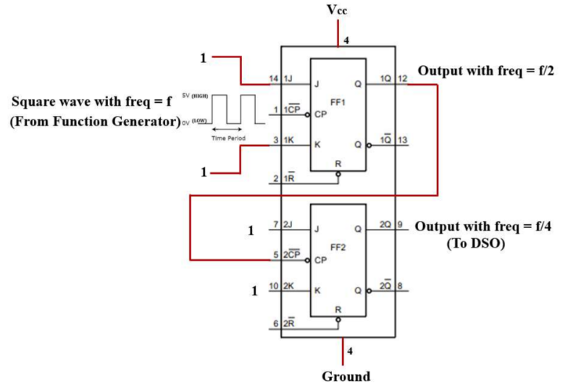

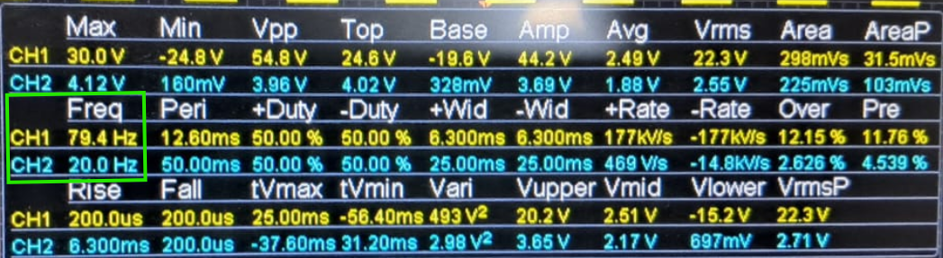

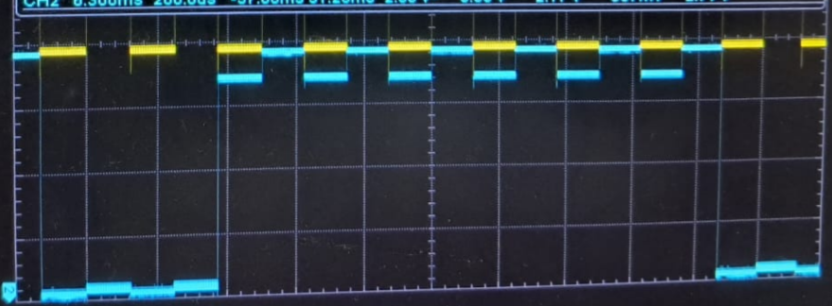 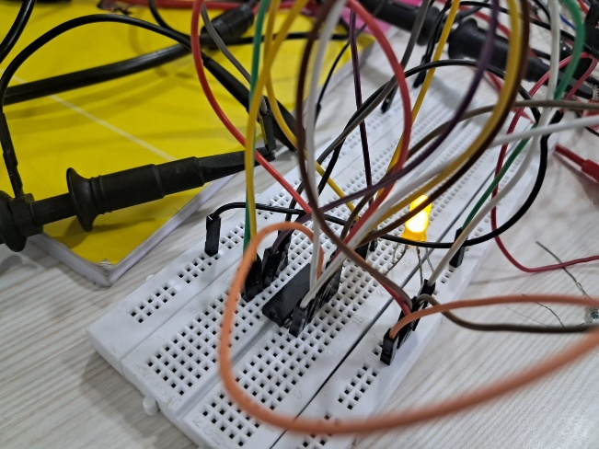

# Results and Conclusion

In this lab session, we explored the operation of the JK flip-flop using the 74HC73N IC, a dual JK negative edge triggered flip-flop with clear. We examined its connection diagram and verified the function table by applying various input combinations and observing the corresponding outputs, which matched the expected behaviour. Using this understanding, we constructed a frequency divider circuit that successfully divided the input clock frequency by 4. By cascading two JK flip-flops and configuring them in toggle mode (J = K = 1), we achieved a square wave output of frequency f/4 for a given input clock of frequency f. The output was tested with different input frequencies, and the observed output frequencies confirmed the correct division, demonstrating the practical application of JK flip-flops in frequency division and digital timing systems.

1. Counters using JK Flip Flop

In partnership with Aditya Pratap Singh (22020)

# Objective

Design counters using JK flip-flops

# Materials Required

* Breadboard
* DC power supply
* JK Flip-Flop IC (74HC73N)
* LED
* Signal Generator
* Connecting wires

# Procedure

1. Connect the circuit as shown in the circuit diagram.
2. Check the LEDs before connecting to the circuit. (Connect anode to positive and cathode to negative terminals of the battery)
3. Don’t increase the voltage by more than 5V.
4. For logic 1 as input, connect the respective terminal to +Vcc.
5. For logic 0 as input, connect the respective terminal to the Ground.
6. Connect the PRE pins to logic 1.

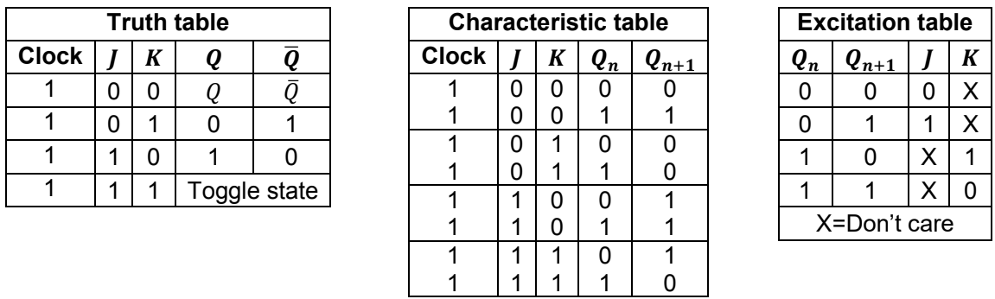

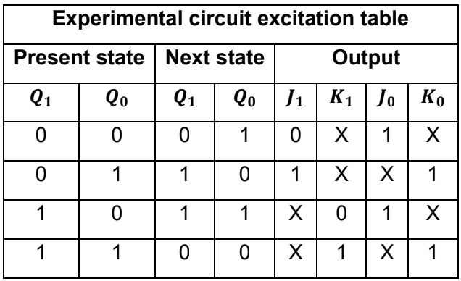 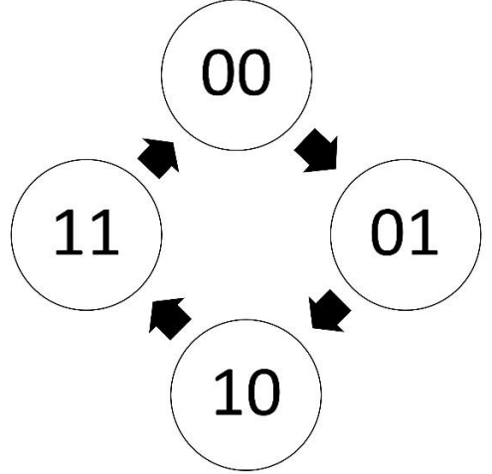

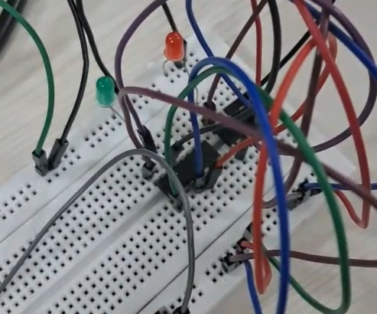 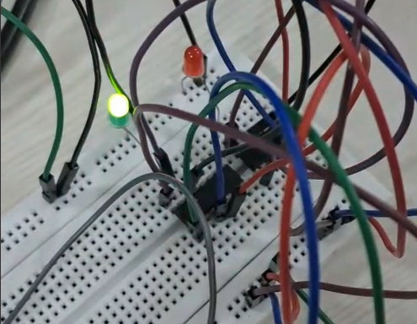

1. **01**

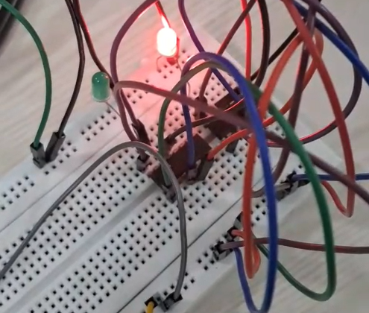 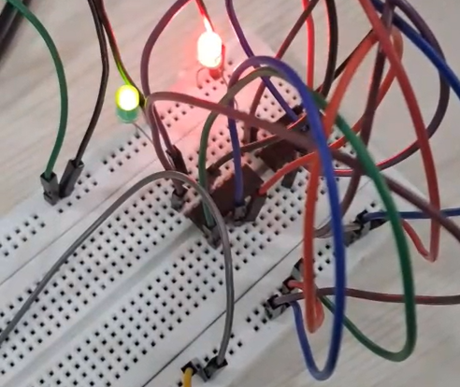

**10 11**

# Result and Conclusion

In this experiment, we successfully designed and implemented a 2-bit binary counter using JK flip-flops. By configuring two JK flip-flops in a cascaded manner with both J and K inputs tied high (logic 1), we enabled toggle functionality on the negative edge of the clock. The first flip-flop toggled with every clock pulse, while the second flip-flop toggled with the output of the first, effectively counting in binary from 00 to 11 (0 to 3 in decimal) and then repeating. The outputs were observed and verified for each clock cycle, and the counter behaved as expected, accurately cycling through the 2-bit binary sequence. This demonstrated the utility of JK flip-flops in sequential logic design, particularly in implementing simple synchronous counters.

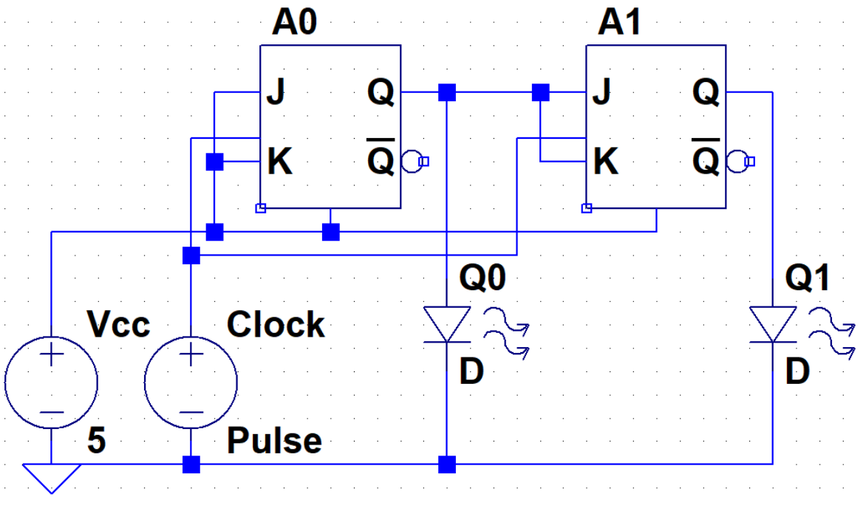

1. Simulation of MOSFET and CMOS

In partnership with Aditya Pratap Singh (22020)

# Objective

This experiment aims to understand the LTspice simulation with experimental plots:

1. the transfer characteristics and output characteristics of n-channel enhancement-type MOSFETs
2. the transfer characteristics and output characteristics of p-channel enhancement-type MOSFETs, and
3. the voltage transfer characteristics (VTC) of a CMOS inverter by connecting the n-MOSFET and p-MOSFET.

Requirement is only a PC with LTSpice installed.

# Objetive 1 (NMOS)

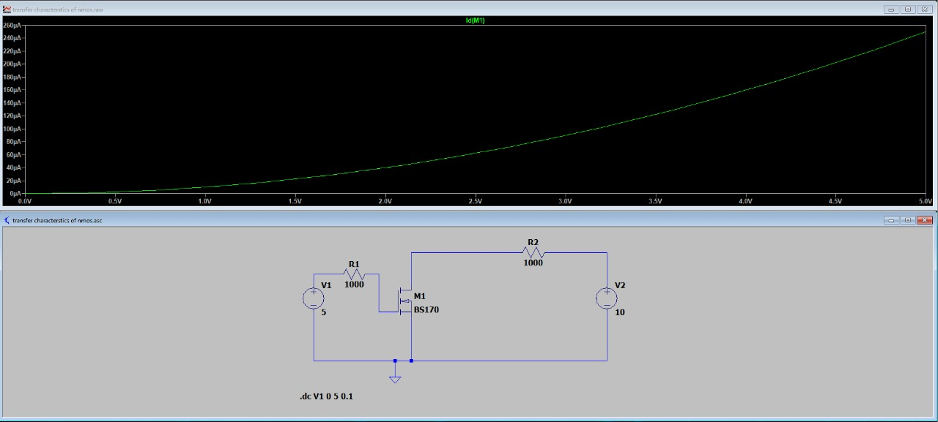

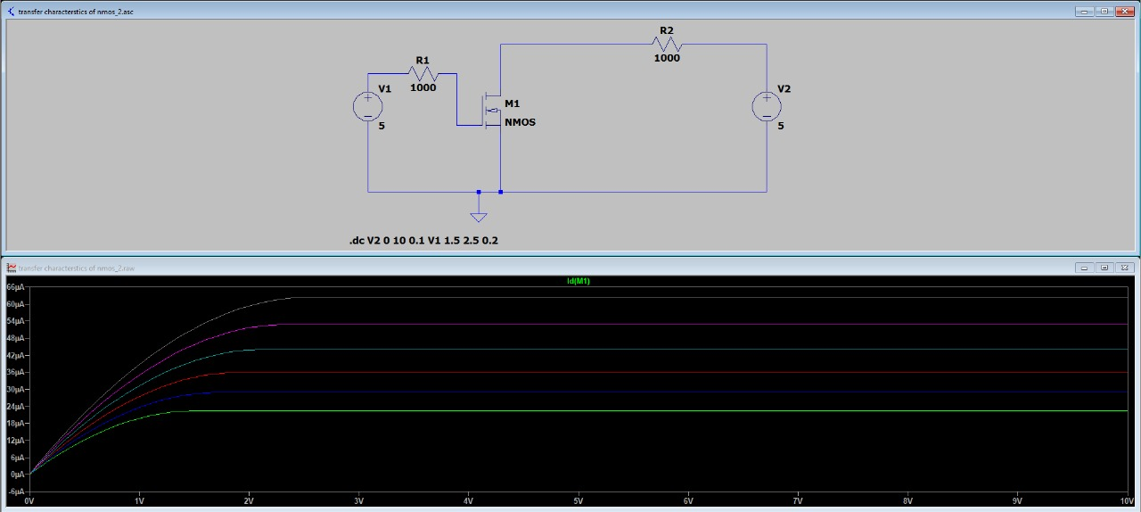

Above is the transfer and below are the output characters of the NMOS.

# Objective 2 (PMOS)

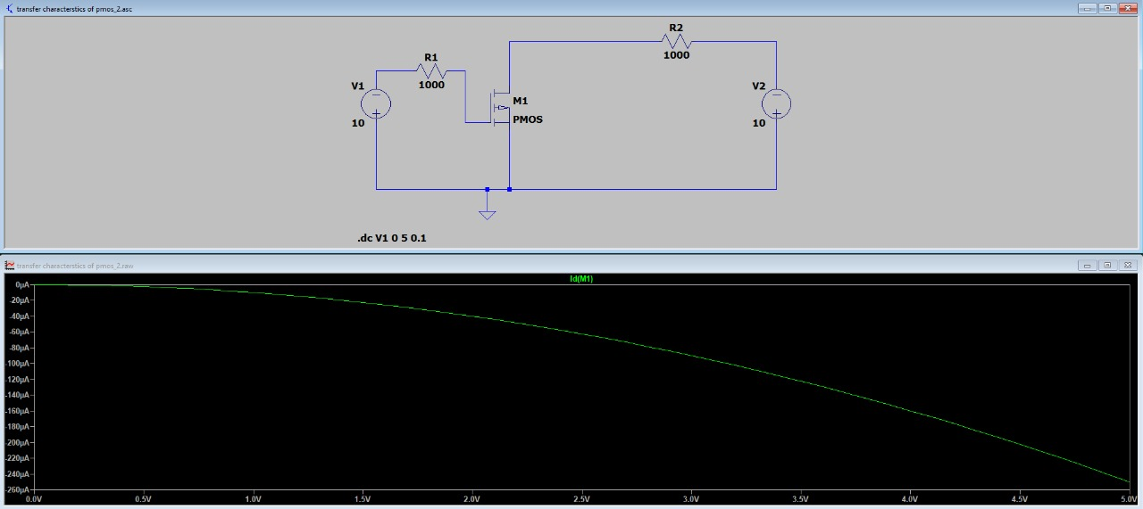

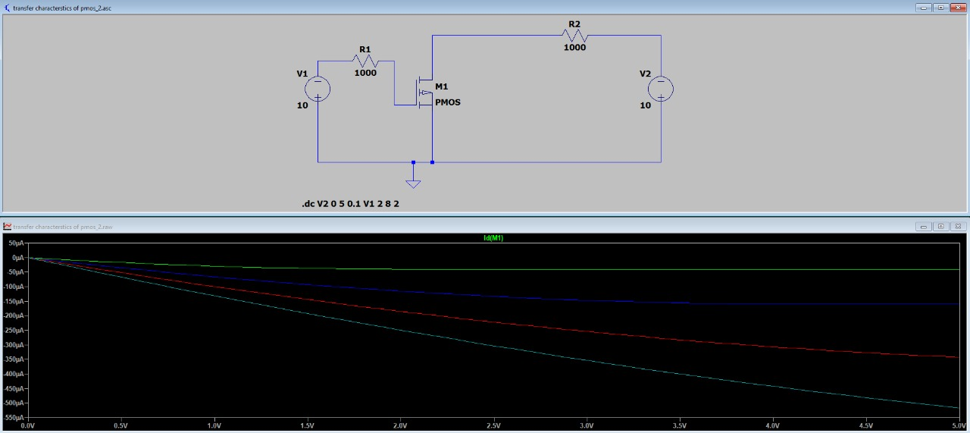

Above is the transfer and below are the output characters of the PMOS.

# Objective 3 (CMOS)

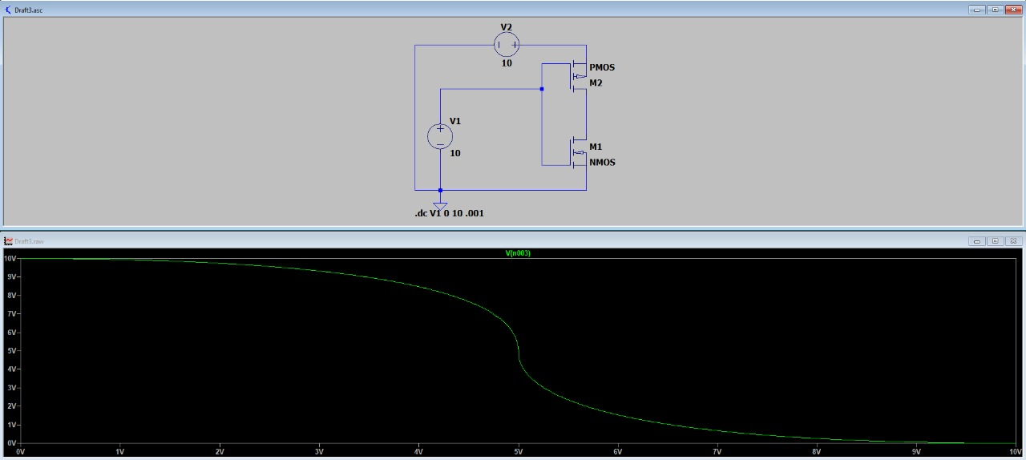

Voltage Transfer characteristics of CMOS.

# Results and Conclusion

In this experiment, we used LTspice to simulate and analyse the electrical behaviour of enhancement-type n-channel and p-channel MOSFETs, as well as a CMOS inverter. The transfer characteristics (Id vs. Vgs) for both NMOS and PMOS were plotted, revealing the threshold voltages and showcasing the gradual increase in drain current with increasing gate voltage beyond the threshold. The output characteristics (Id vs. Vds) were also obtained for different gate voltages, clearly illustrating the distinct linear and saturation regions of operation. Finally, we constructed a CMOS inverter using both NMOS and PMOS transistors and plotted its voltage transfer characteristics (Vout vs. Vin). The VTC curve confirmed the inverter action with a sharp transition near the midpoint of the supply voltage, demonstrating its switching behaviour. These simulations validated theoretical expectations and provided deeper insights into MOSFET operation and CMOS logic design.